<https://share.icloud.com/photos/0eeM9qJ6tOmjzeObW6ovzmH1g>

We need 2 photos for the bracelet version of the newly retouched necklace.

One for the flat surface and the other for the patterned one.

Please use this image as a reference for the angle and the clasp placement.

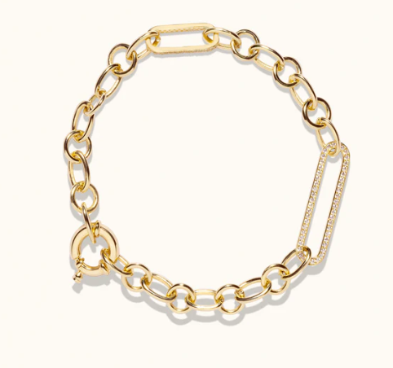

And the color tone must be the same tone that you applied to the necklaces