Could you use the color of this ring as a reference for the chain?

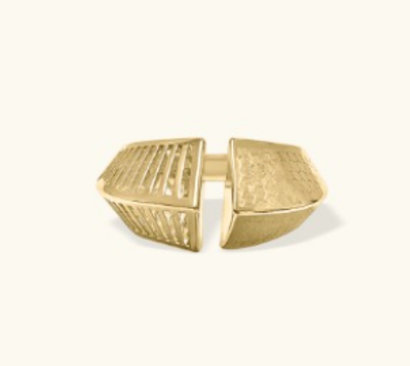

Thank you once again for the retouched images. The overall cleanup looks good, but we’d like the color tones to be slightly adjusted. The current gold looks a bit too bright and artificial compared to the real product. Could you make the tone warmer and closer to the original gold color?

Also, please keep the natural highlights and shadows more visible, especially on the flat-surfaced chain, so the product looks more realistic and premium