Thanks. For the product photos, we kindly ask that both the pendant alone and the pendant with chain be photographed from a direct front angle, similar to the attached reference image.

Like this

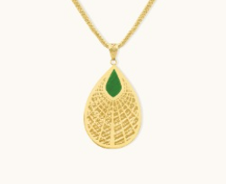
And the color tone should be like the ring

