Looks great, thank you! We just need to adjust the color tone. Additionally, could you please make the honeycomb pattern a bit more prominent?

For the color tone, please use the pendant below as a reference.

image.png

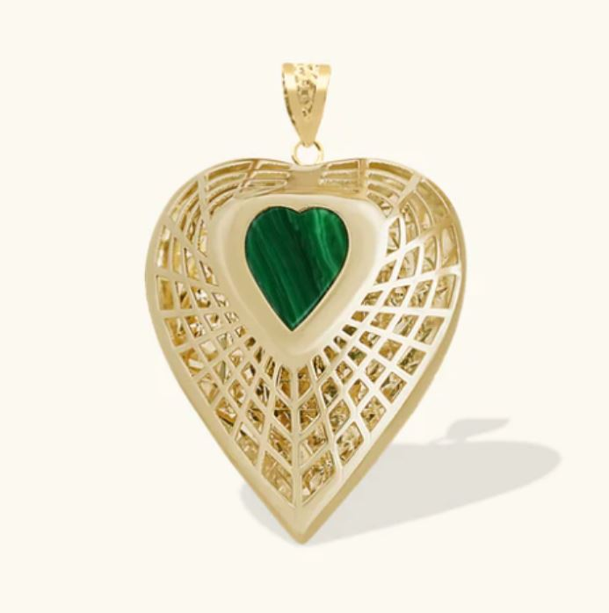

Could you please apply the same tone on the right photo as well?

This one I mean
image.png

