SSE10100SS-BOX-7.5 Pendant

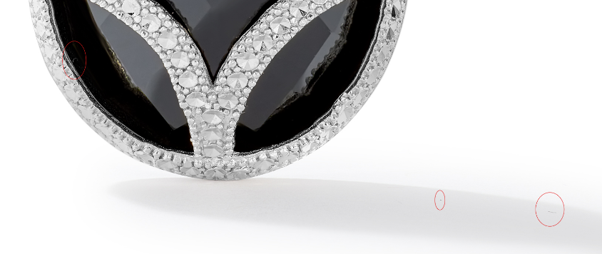

SSE10100SS-BOX-7.5 Earring

clean up marks, update correct links

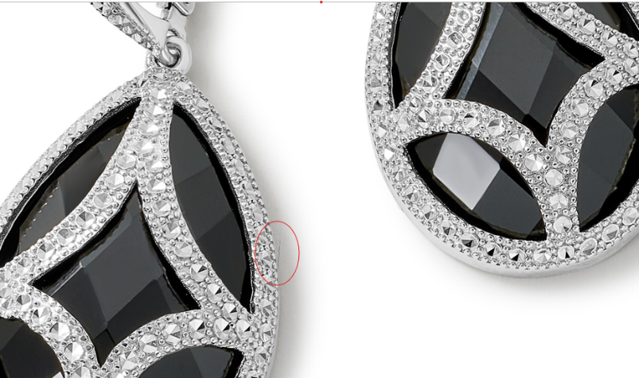

GCH20085Y4-0-0
clean up marks, update correct links
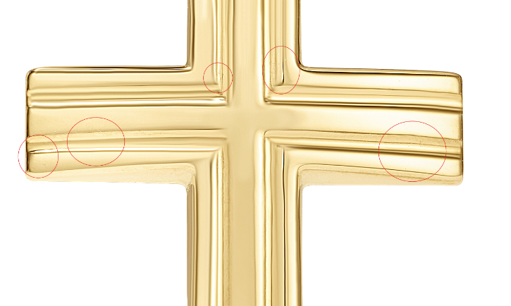

GCH15428Y4-0-0
clean up marks
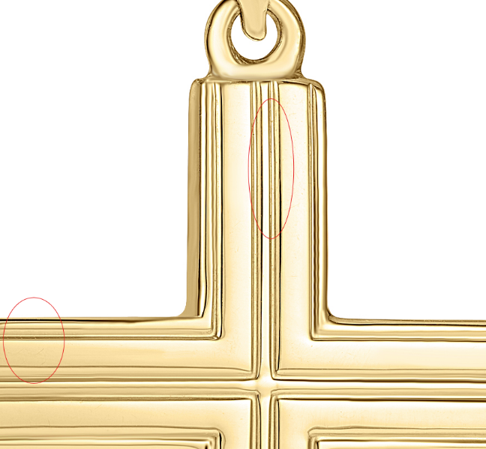

GHP20345Y0-0-0
clean up marks
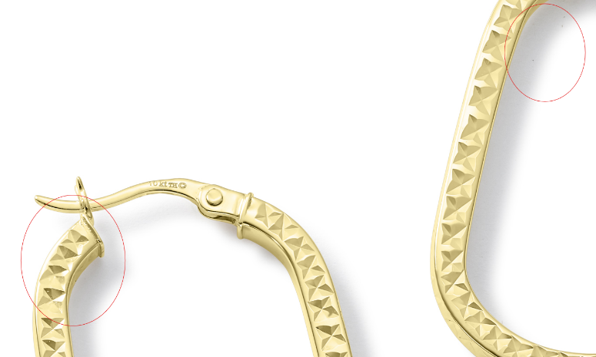
GHP20345W0-0-0
clean up marks
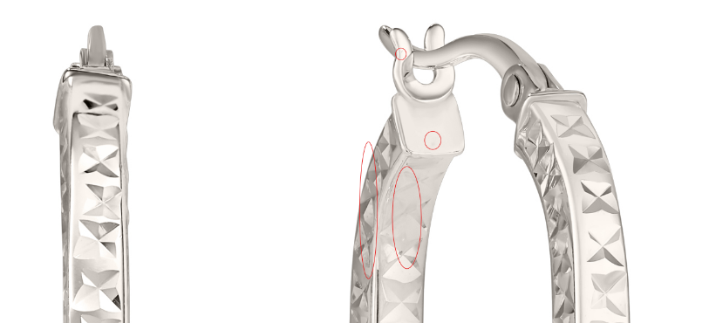

GCH15417W4-0-0
clean up marks, fix links
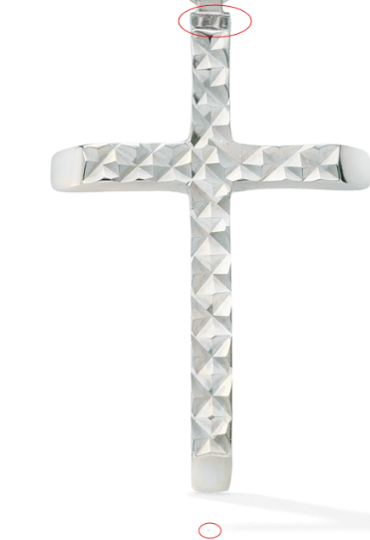

GCH15417Y0-0-0
needs model shot, fix links

Use chains in this folder: Chains for Model_Yellow
Please create the following:
A Shot - Just pendant retouched
B -Pendant plus 20-inch Chain together
C -Pendant plus 18-inch Chain
Ruler Image
Model Image with pendant 2 lengths
See example here: Pendant Sample

GHP15746W0-0-0
clean up marks
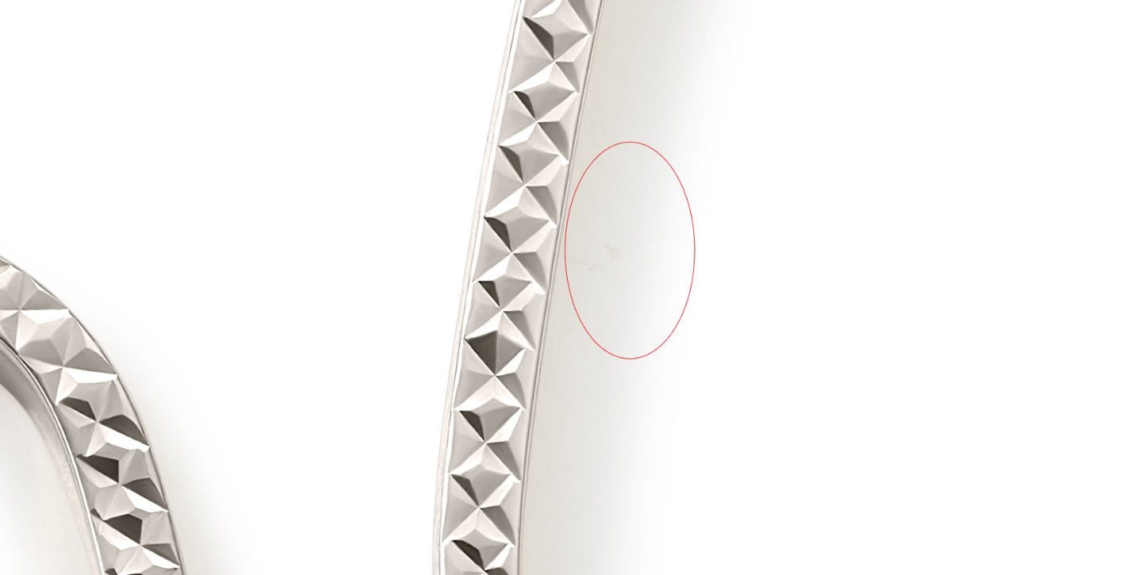

GHP15997W4-0-0
clean up marks
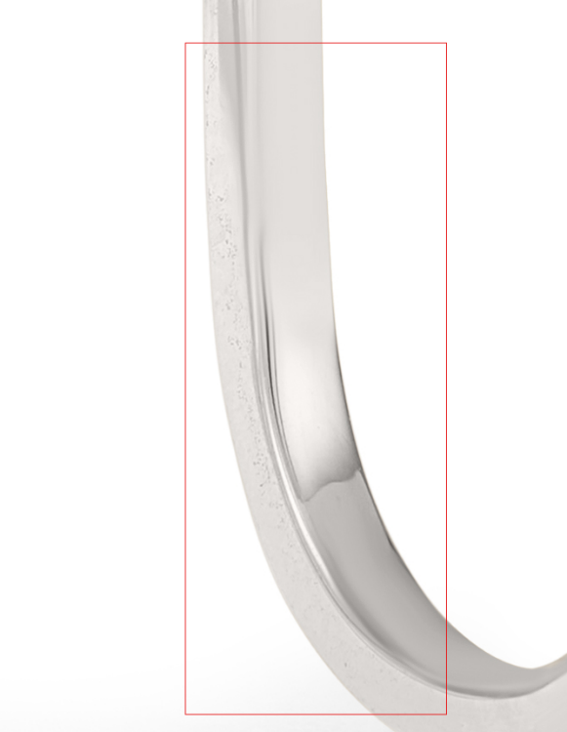

GHP20237W4-0-0
Please clean up any noticeable marks
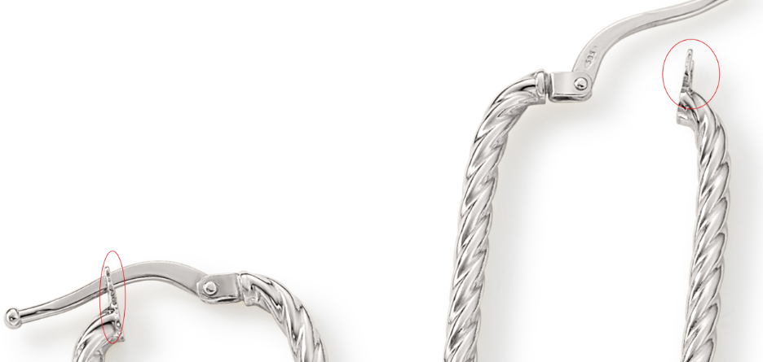

GEG16170Y0-0-0
clean up marks
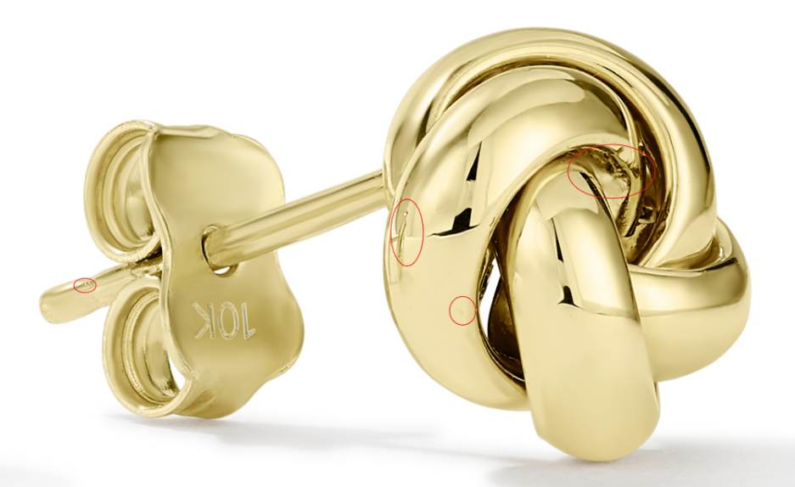

GEG17748W4-0-0
clean up marks
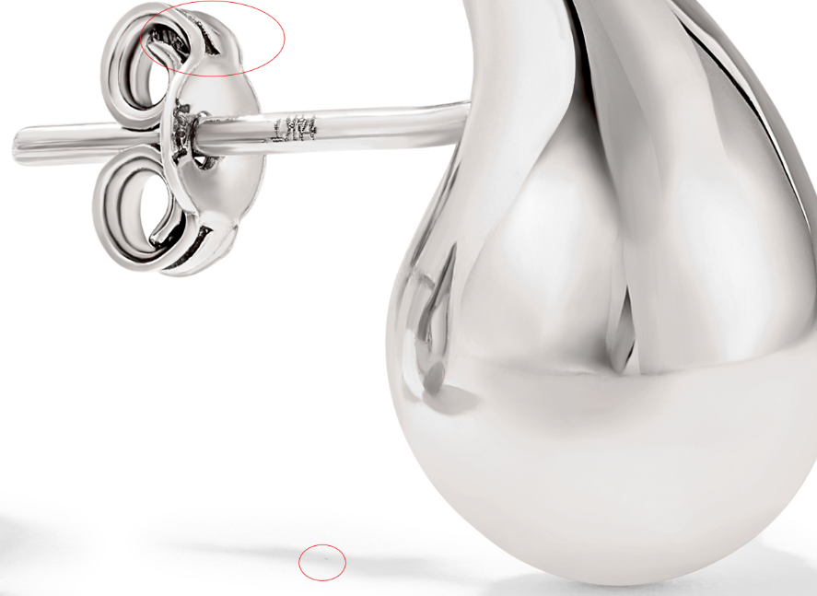

GHP20094Y0-0-0
clean up marks, fix links
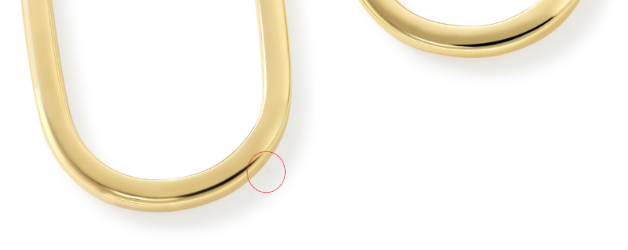

GHP15746Y0-0-0
clean up marks

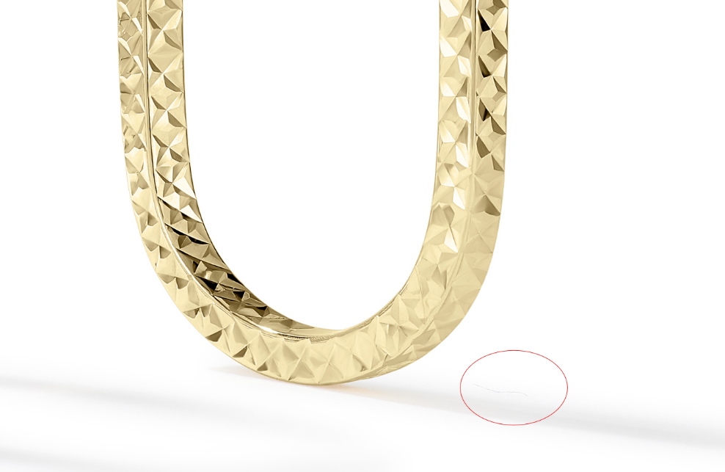

GRG11609Y4-0-7
clean up marks, fix links
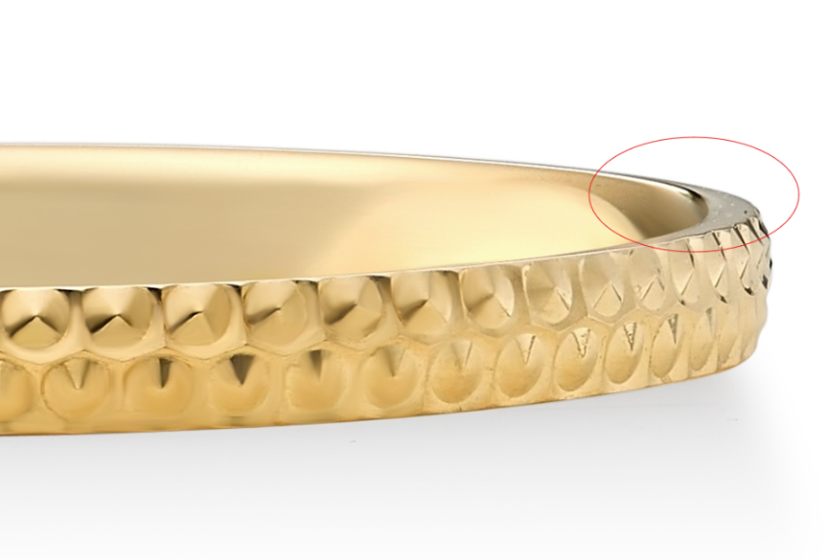

GRG11582Y4-0-7
clean up marks
