GHP15746W0-0-0
clean up marks
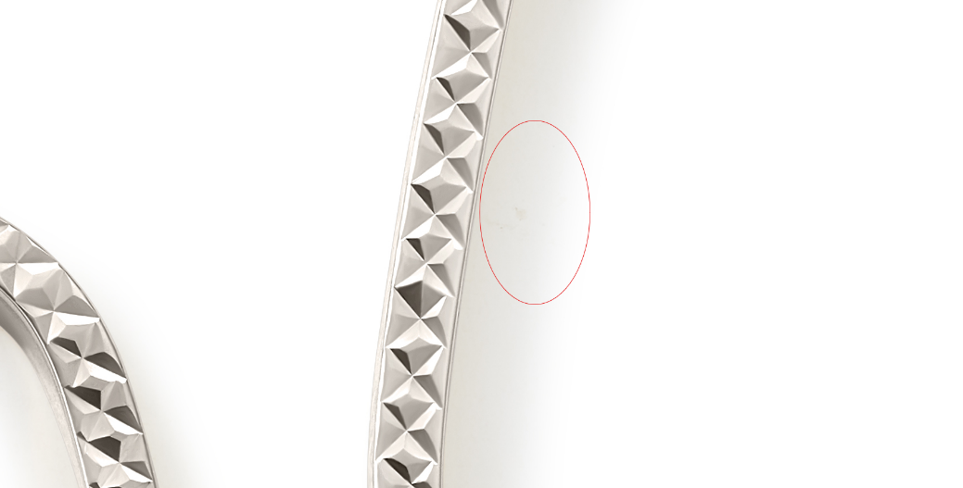

GHP15997W4-0-0
clean up marks
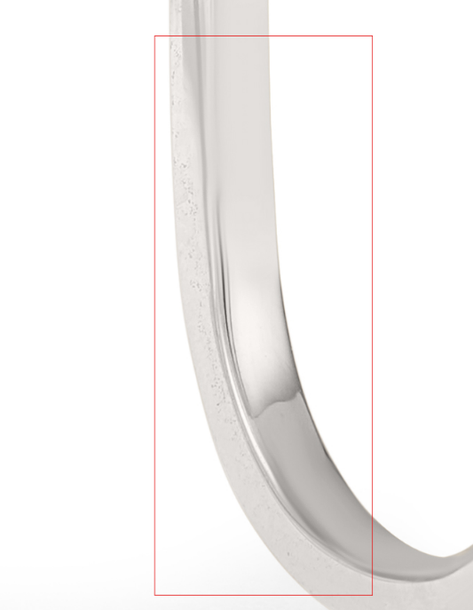

GHP20094W0-0-0
clean up marks
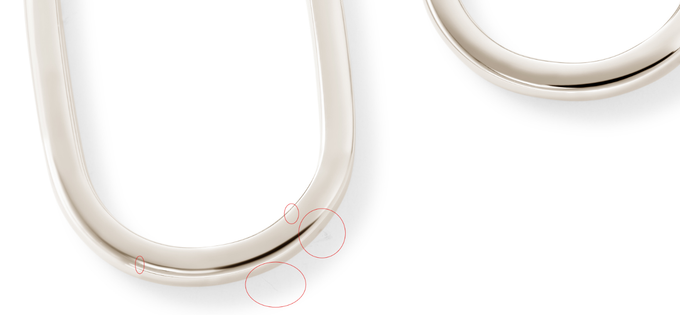

GHP20237W4-0-0
Please clean up any noticeable marks
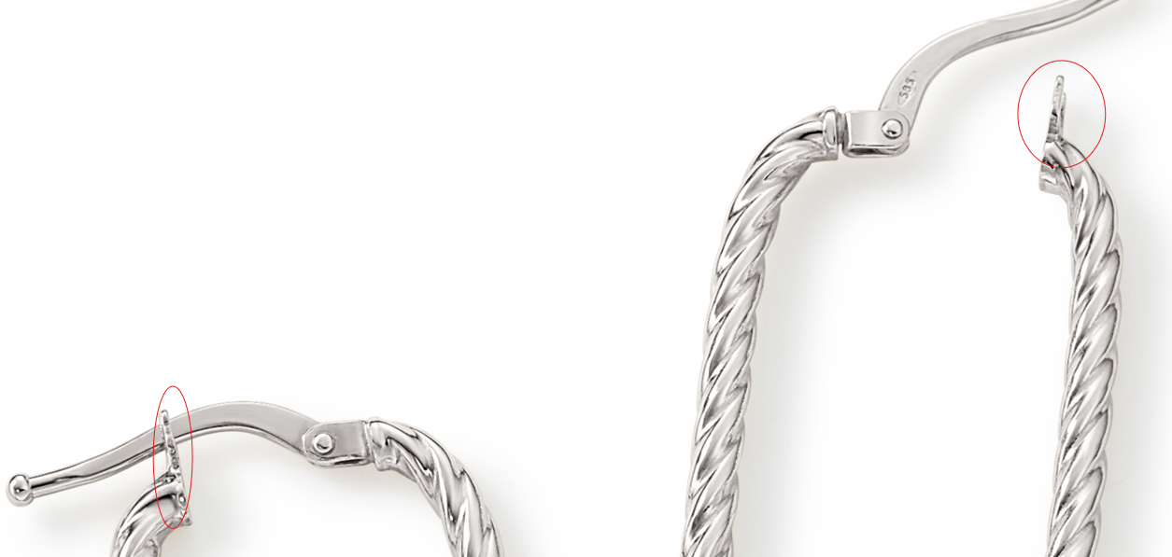

GHP20094W4-0-0
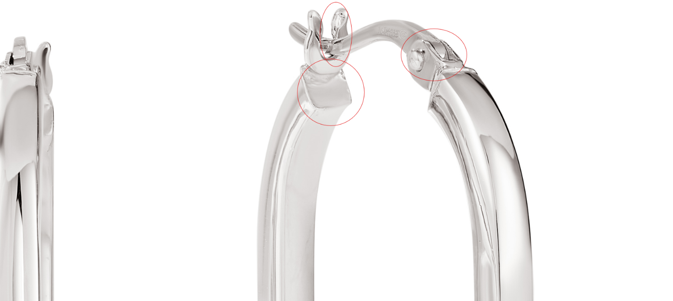

GSE10923Y4-ANDEA-0
Image B is cut off
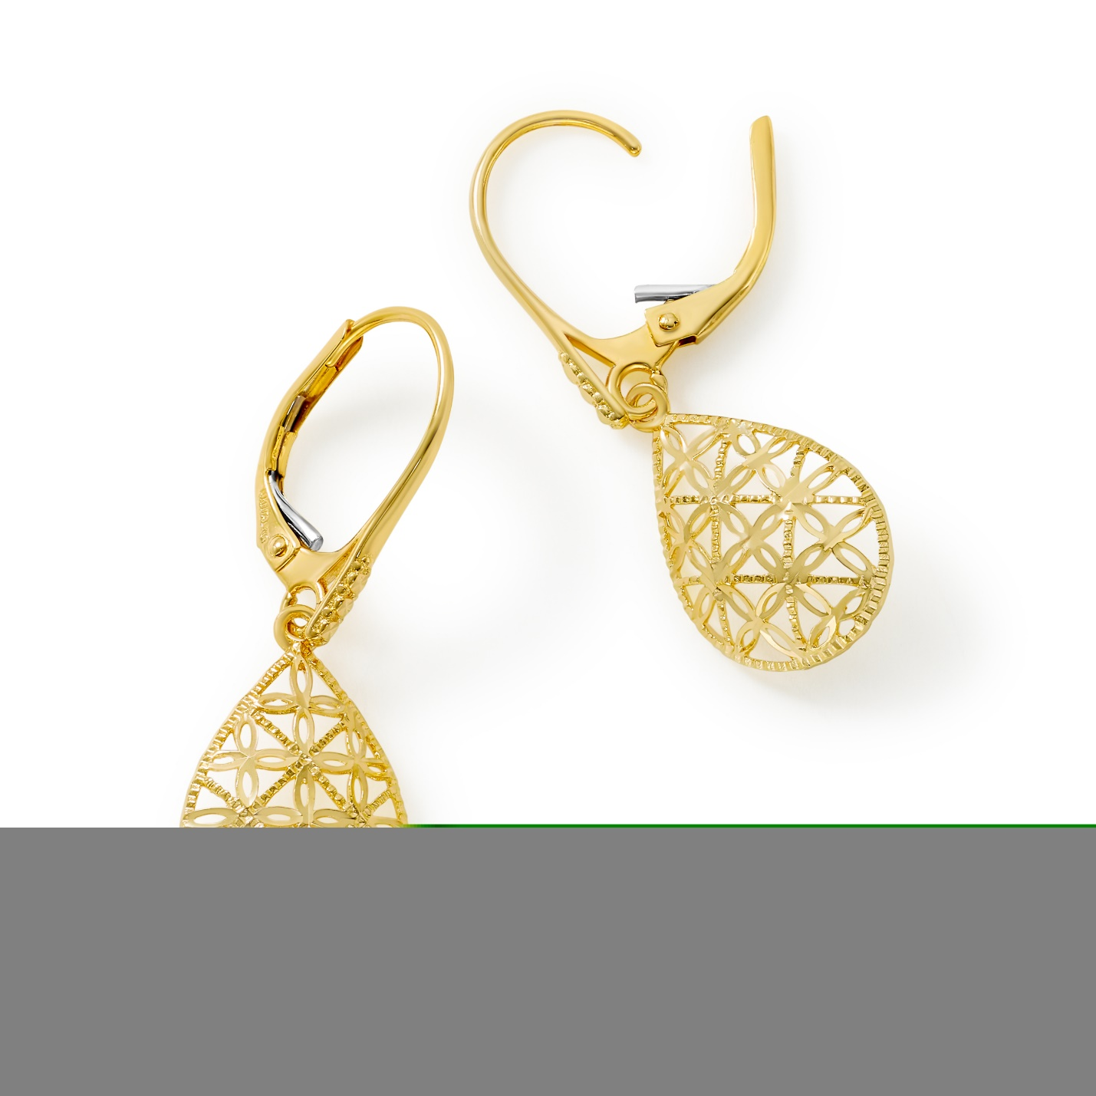

GEG16996Y0-0-0
clean up marks, fix links
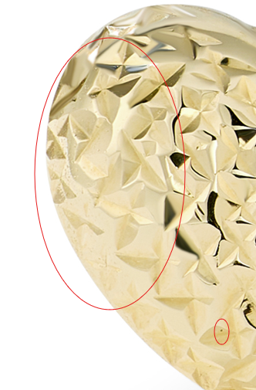

GEG16996W0-0-0
clean up marks
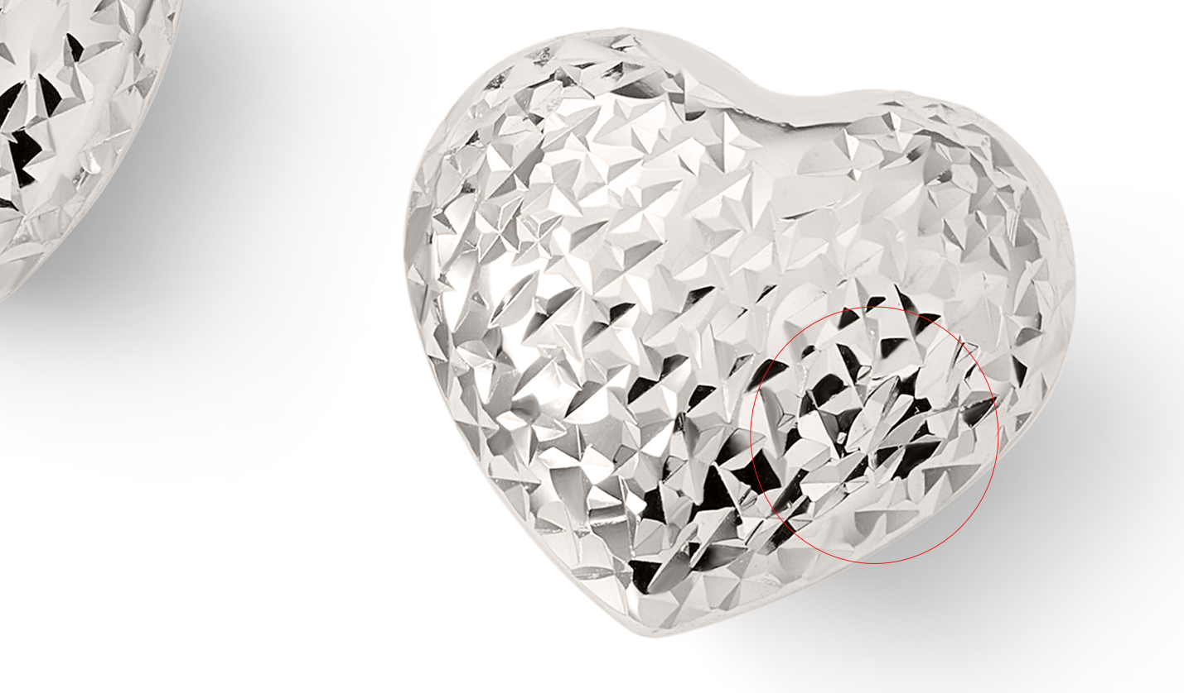

GEG20231Y0-0-0
clean up marks
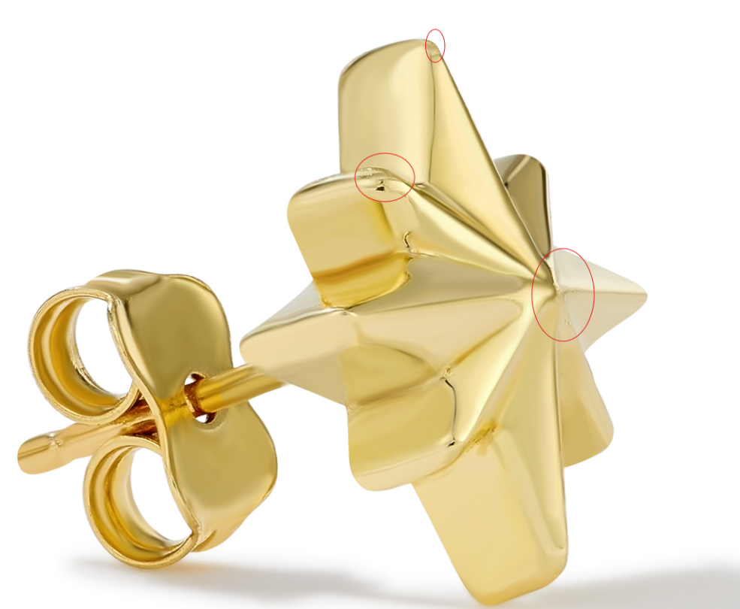

GEG16170Y0-0-0
clean up marks

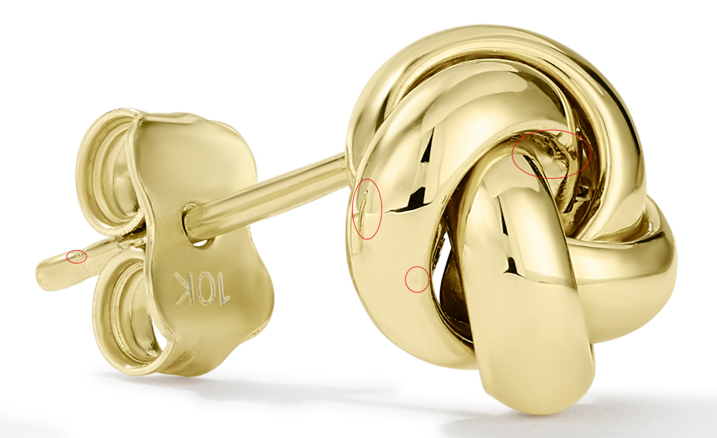
GEG17748W4-0-0
clean up marks
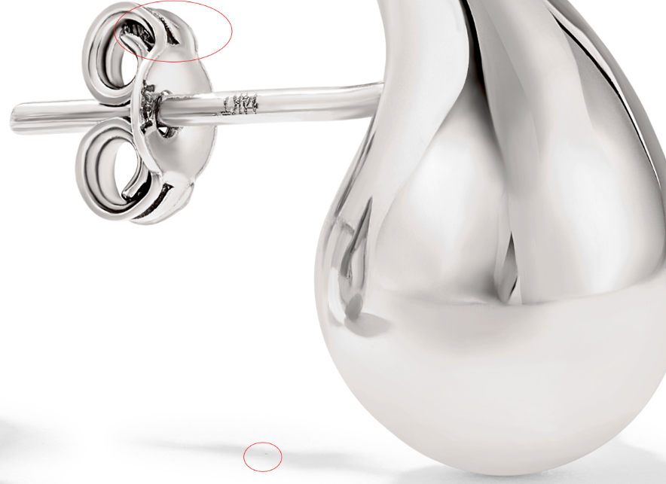

GEG17748W4-0-0
clean up marks
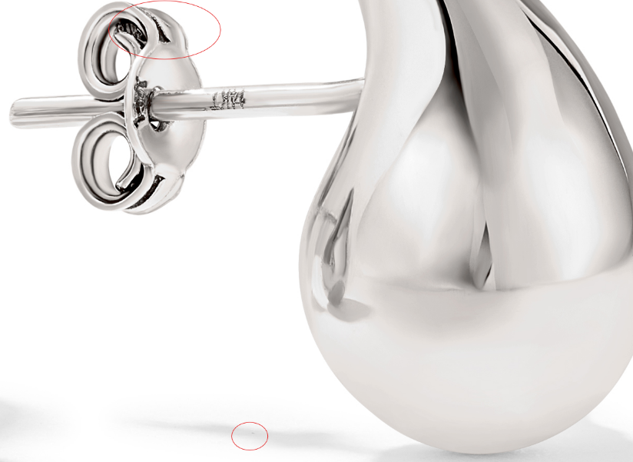

GHP15746Y0-0-0
clean up marks
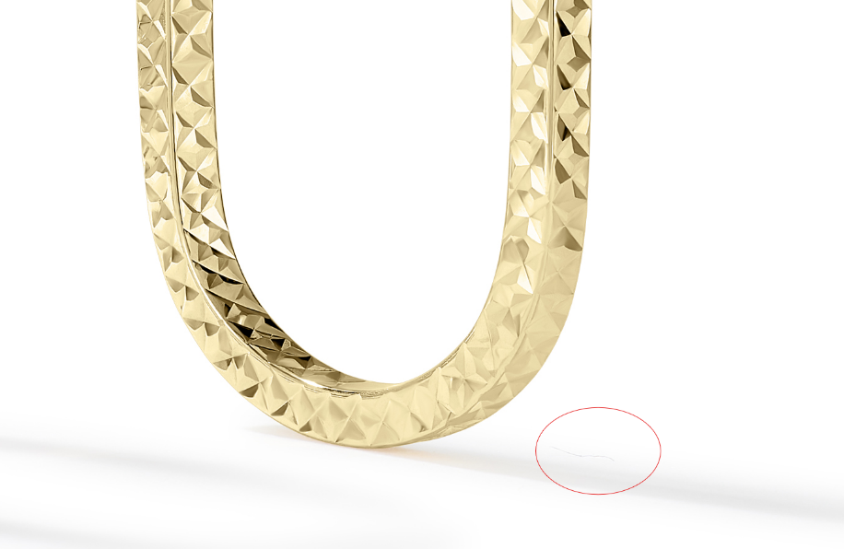
GHP20234Y0-0-0
clean up marks
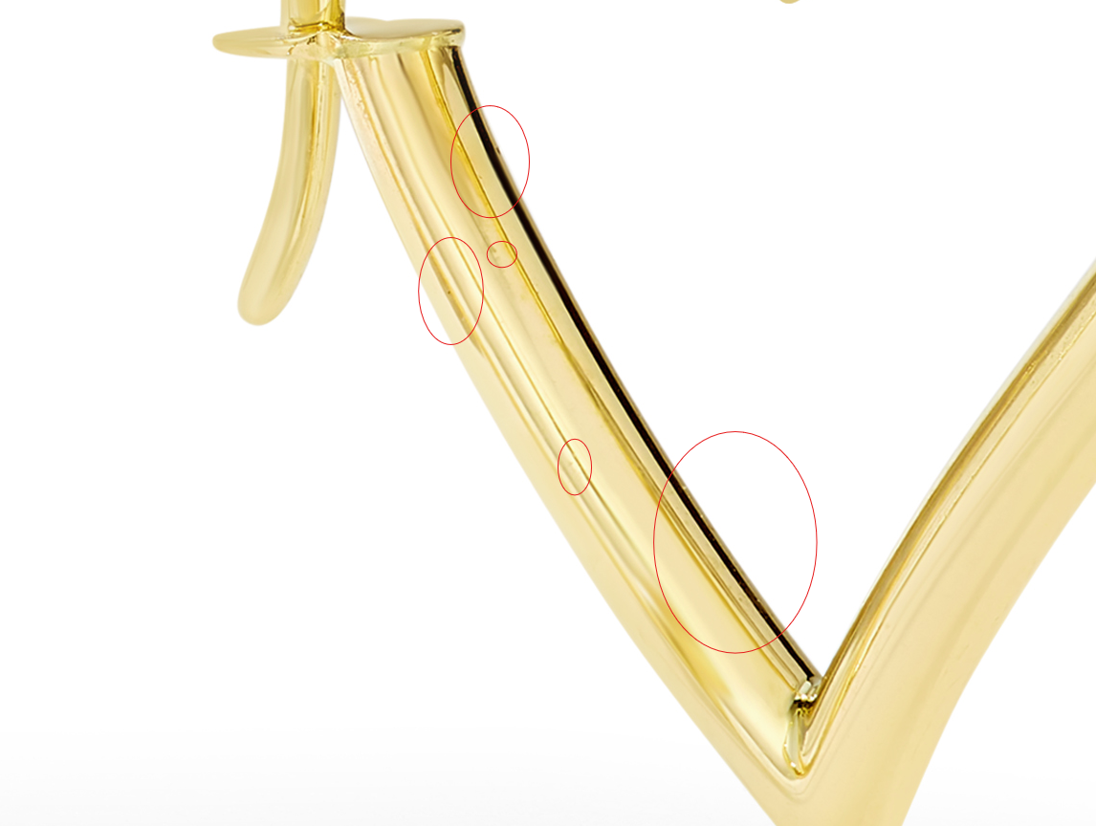

GCH20168T4-0-0
clean up marks
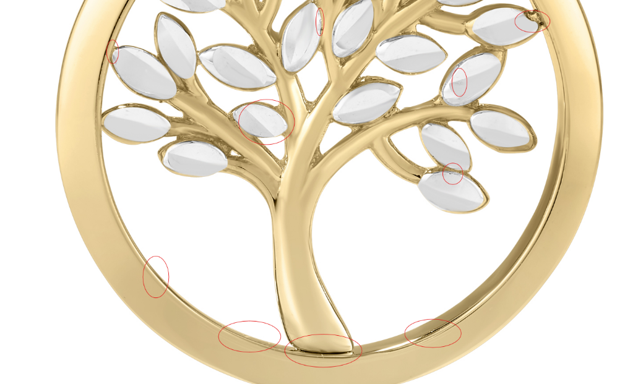

GRG11609Y4-0-7
clean up marks, fix links
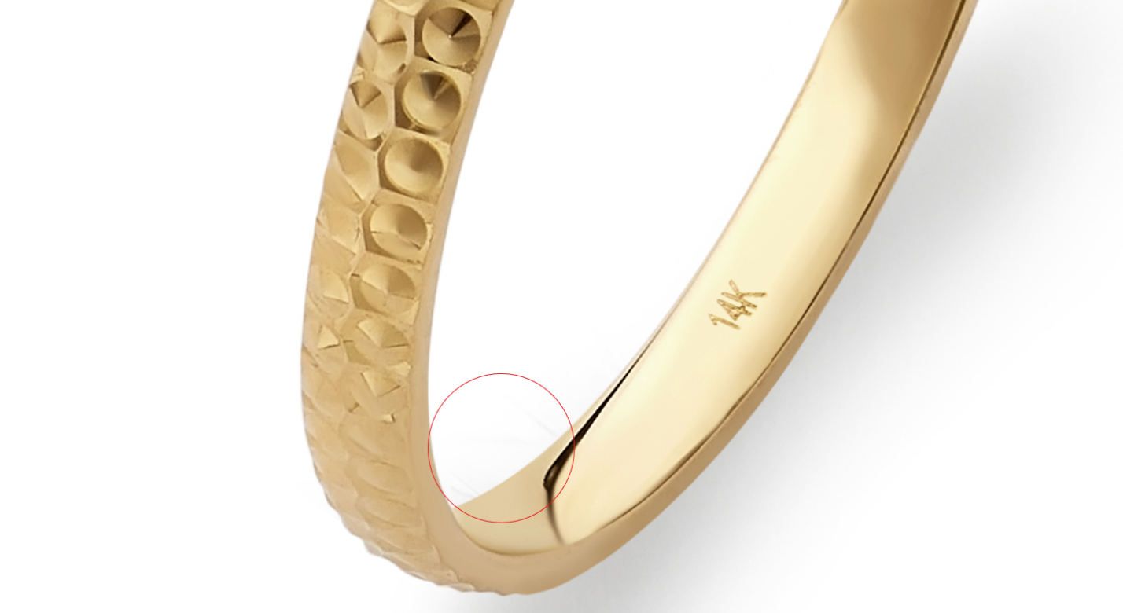

GRG11582Y4-0-7
clean up marks
