GCH15417Y0-0-0
clean up marks, fix links
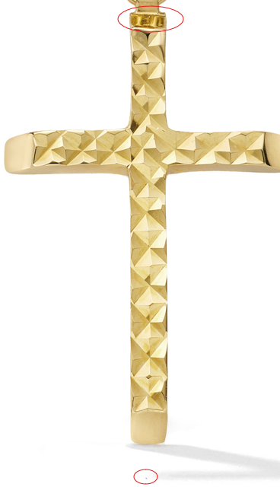

GCH15417W4-0-0
clean up marks, fix links

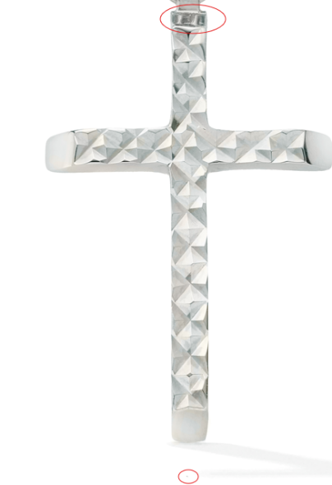

GHP20344Y4-0-0
Height: 22.3mm
Width: 13.6mm
Thickness: 1.45mm

GHP20345W0-0-0
clean up marks

GHP20345W0-0-0
clean up marks

GHP20345Y0-0-0
clean up marks
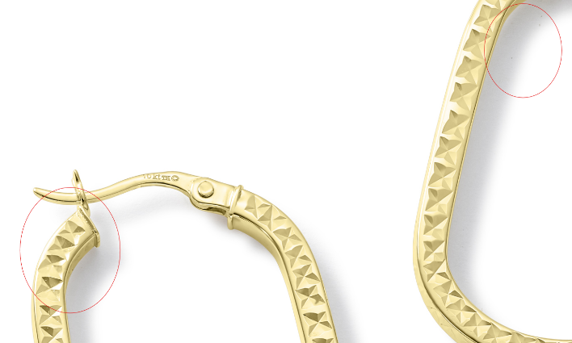

GEG17748W0-0-0
clean up marks, fix links

GEG17748W0-0-0
clean up marks, fix links
GEG17748Y0-0-0
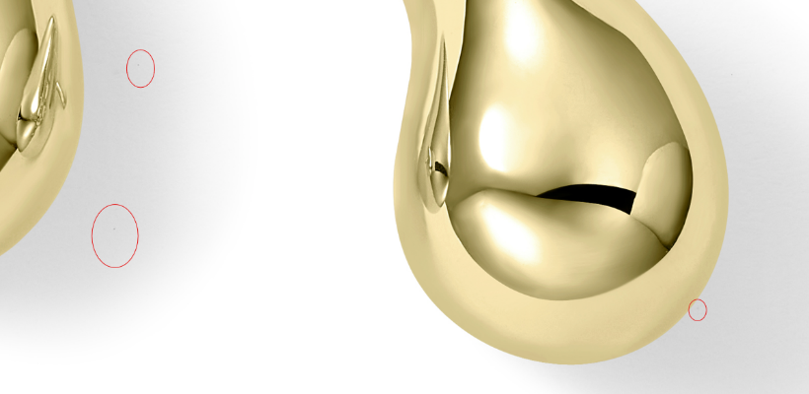

GEG17748Y0-0-0
clean up marks
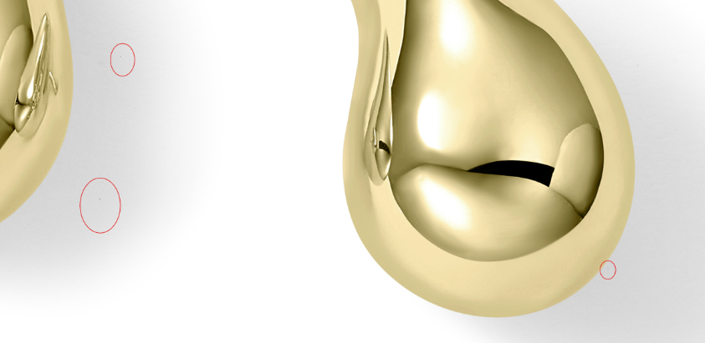

GCH15428Y4-0-0
clean up marks
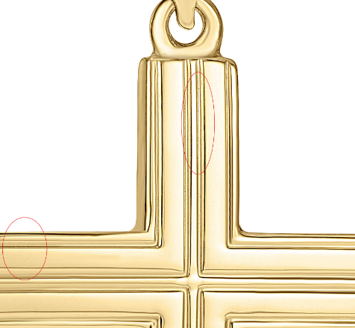

GHP15622Y4-0-0

GHP15995Y4-0-0
clean up marks
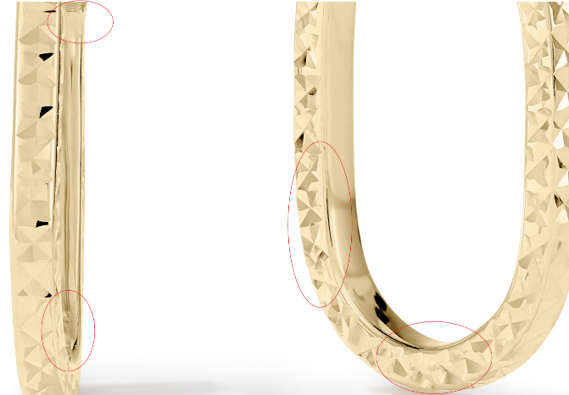

GHP15997Y4-0-0
clean up marks, update correct links
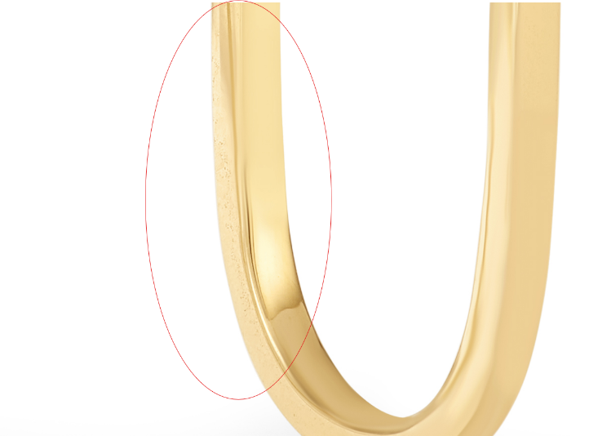

GHP20094Y4-0-0
clean up marks, update correct links
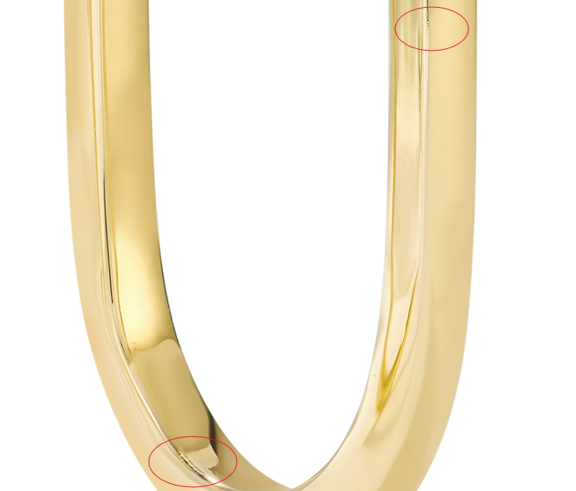

GCH20085Y4-0-0
clean up marks, update correct links
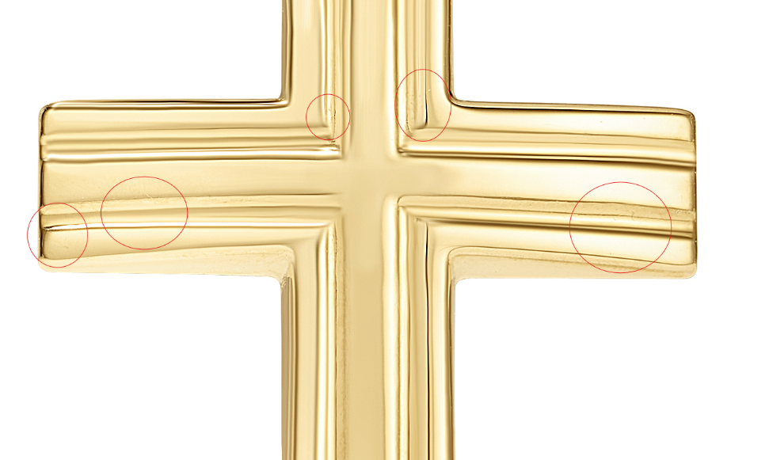

SSE10100SS-BOX-7.5 Earring
clean up marks, update correct links
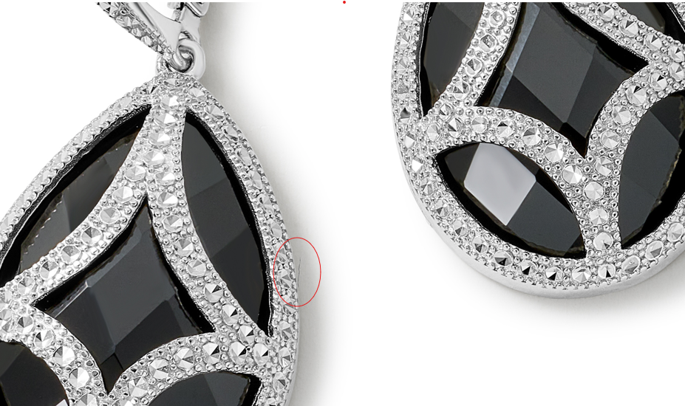

SSE10100SS-BOX-7.5 Pendant
Clean up marks
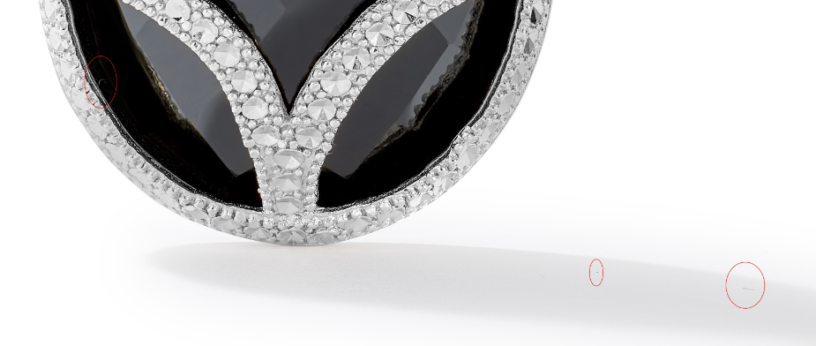
GNK14288Y4-0-18
Polish gold and clean up marks
