GEG20231Y4-0-0
make both sides symmetrical, fix links

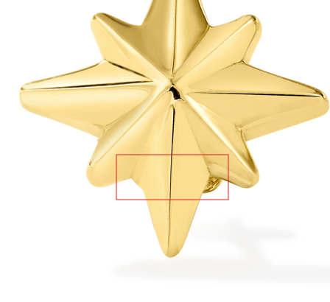

GNK13791R0-ADJ-16.18
make opening a clean even circle, fix links

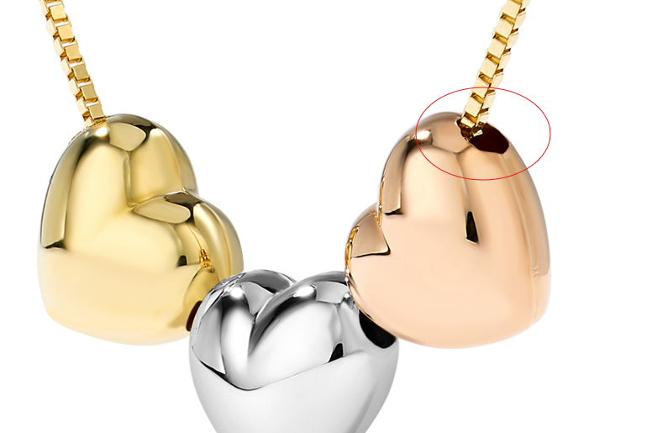

GRG11582Y4-0-7
clean up marks
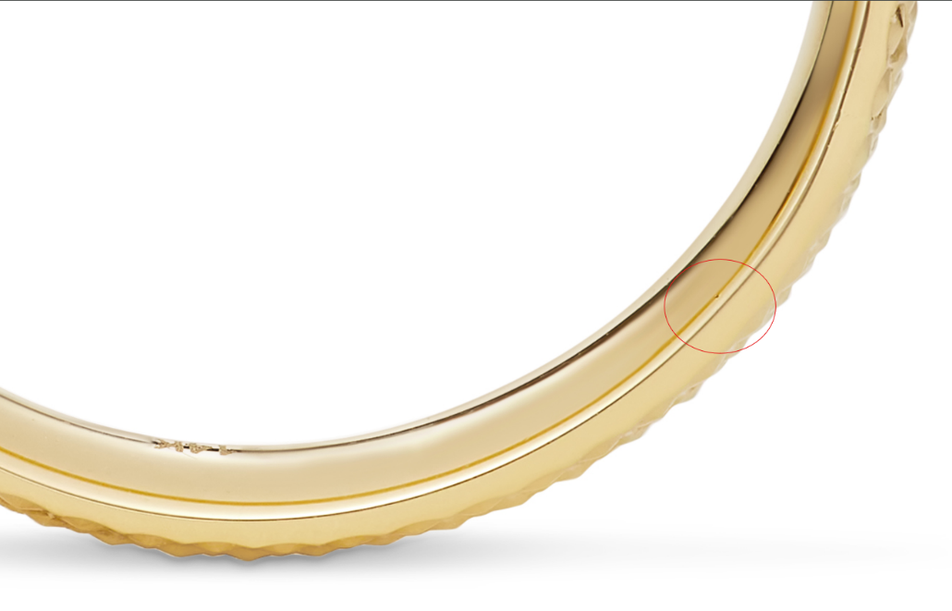

GRG11609Y4-0-7
clean up marks, fix links
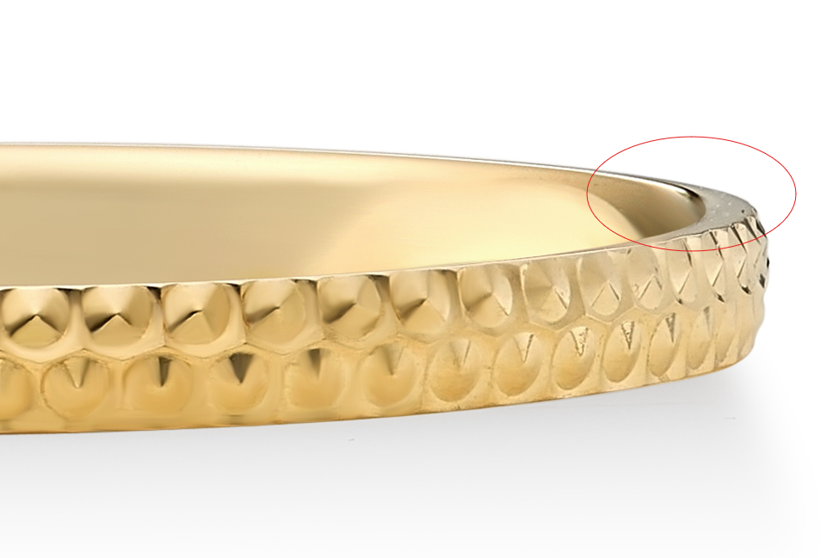
GCH20167R4-0-0
clean up marks, fix color

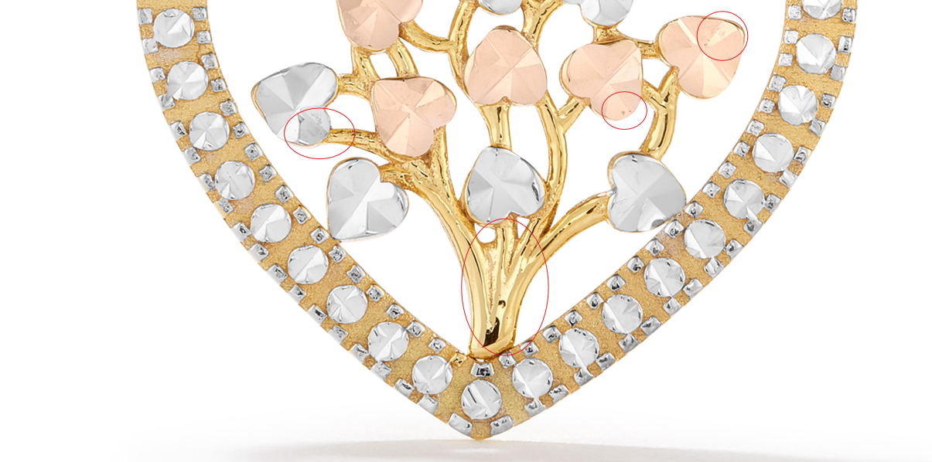
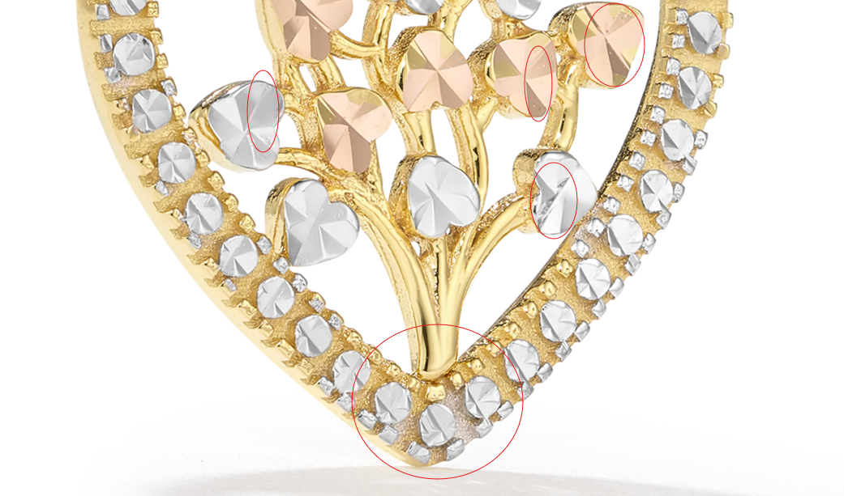

GEG17088Y0-0-0
clean up marks, fix links
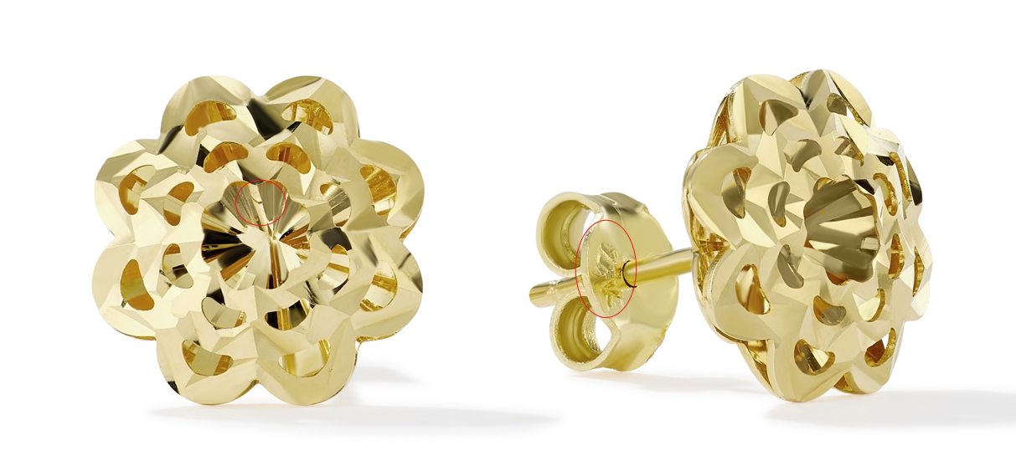

GEG16170Y0-0-0
clean up marks
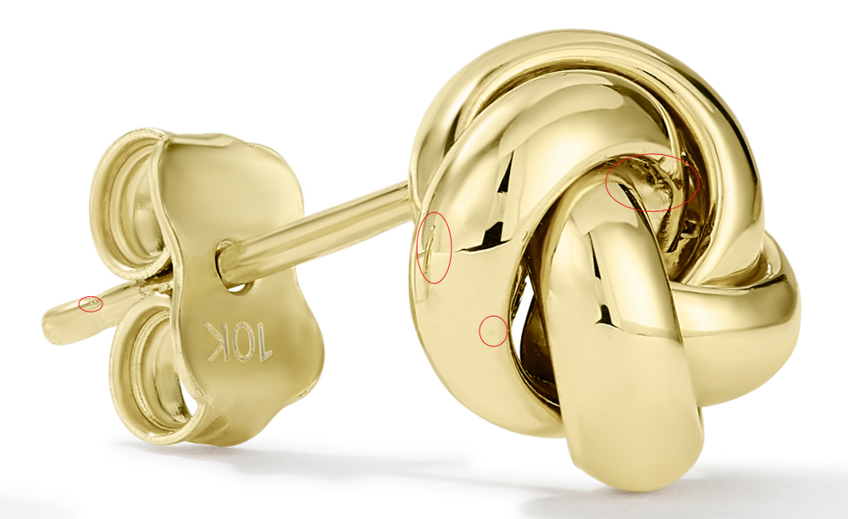

GEG16996W0-0-0

clean up marks
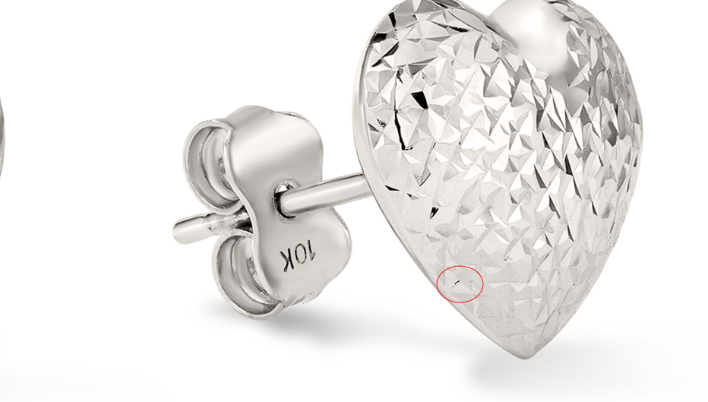
GEG16996Y0-0-0
clean up marks, fix links
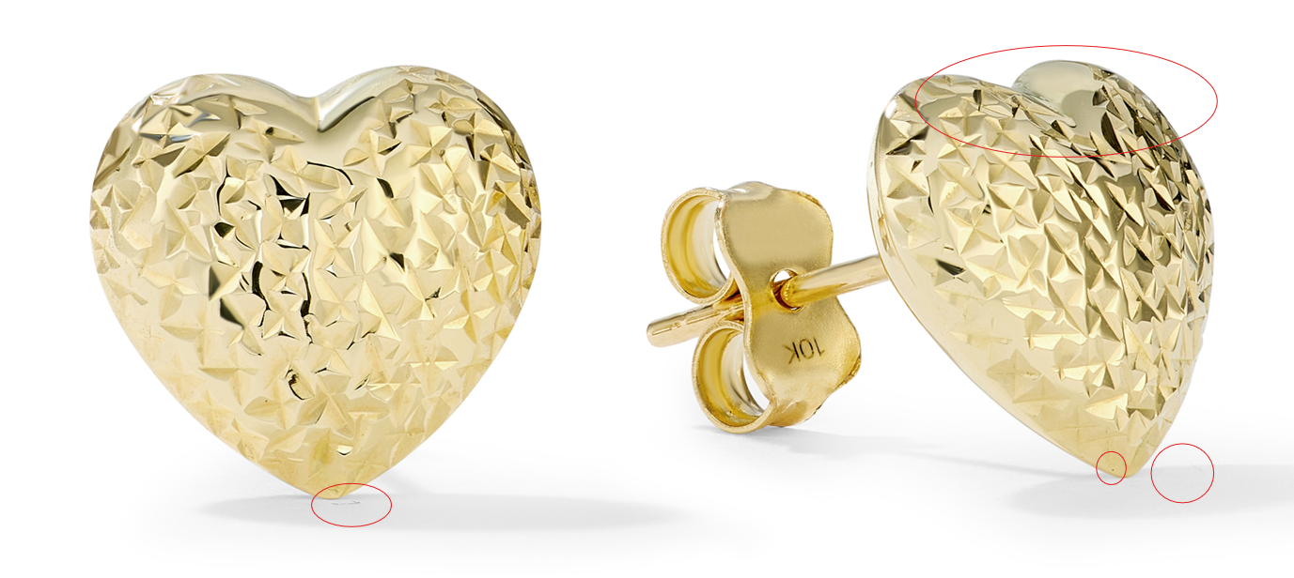

GCH20148Y4-HP-0
Image A and Image B have the opposite links

GCH20098W4-CHN-16.18
needs model shot in White Gold, fix links

GHP20237W4-0-0
Please clean up any noticeable marks
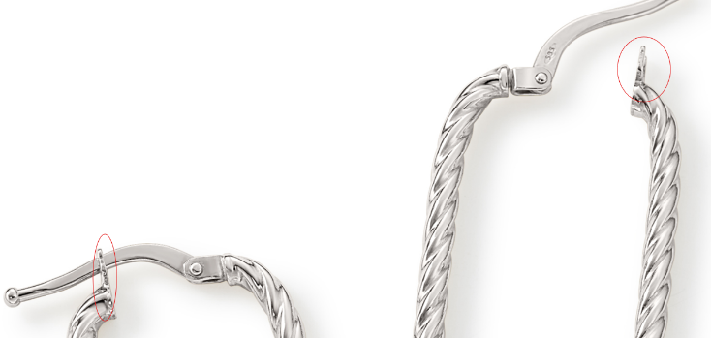

GCH15417Y0-0-0
clean up marks, fix links
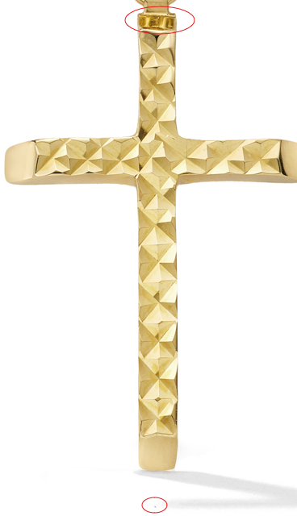

GCH15417W4-0-0
clean up marks, fix links

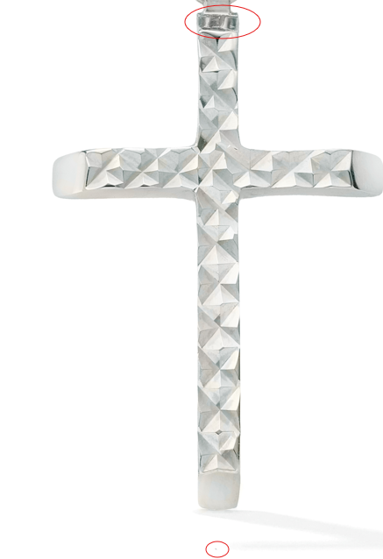

GCH20148W4-HP-0
Please clean up any noticeable marks, fix links
