GNK13791R0-ADJ-16.18

Smooth rough edges
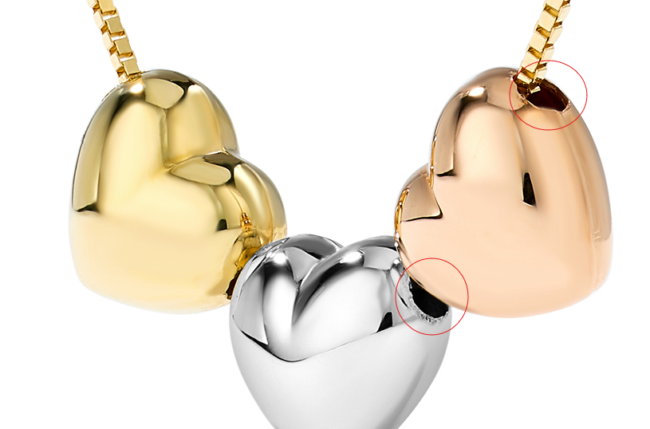
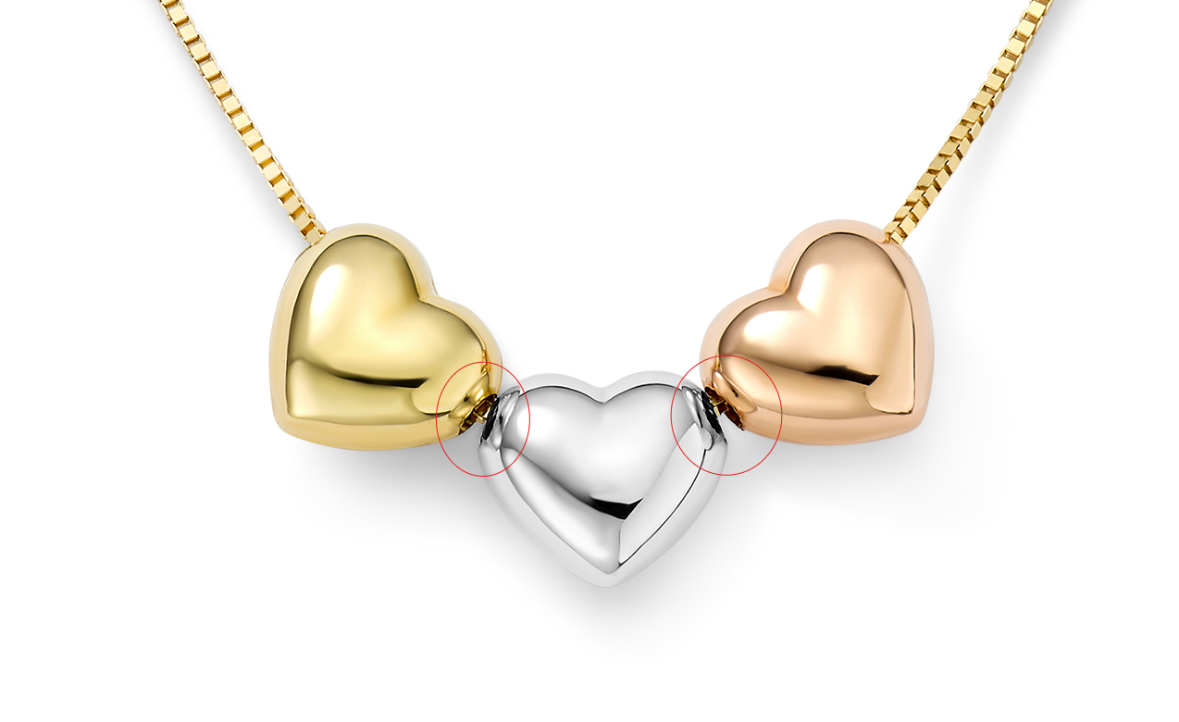

GEG16170Y4-0-0

clean up any marks, fix links
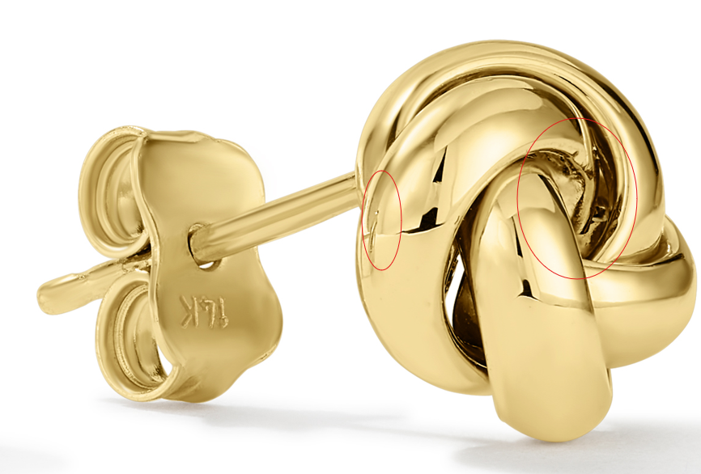

GEG20231Y4-0-0
clean up any marks, fix links

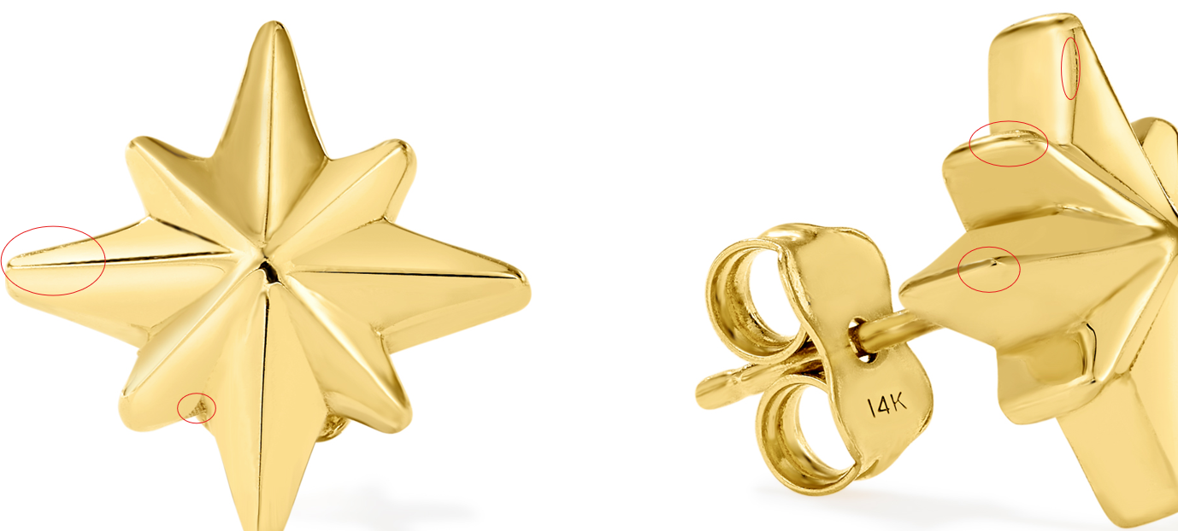
GEG17669Y4-0-0
clean up any marks, fix links
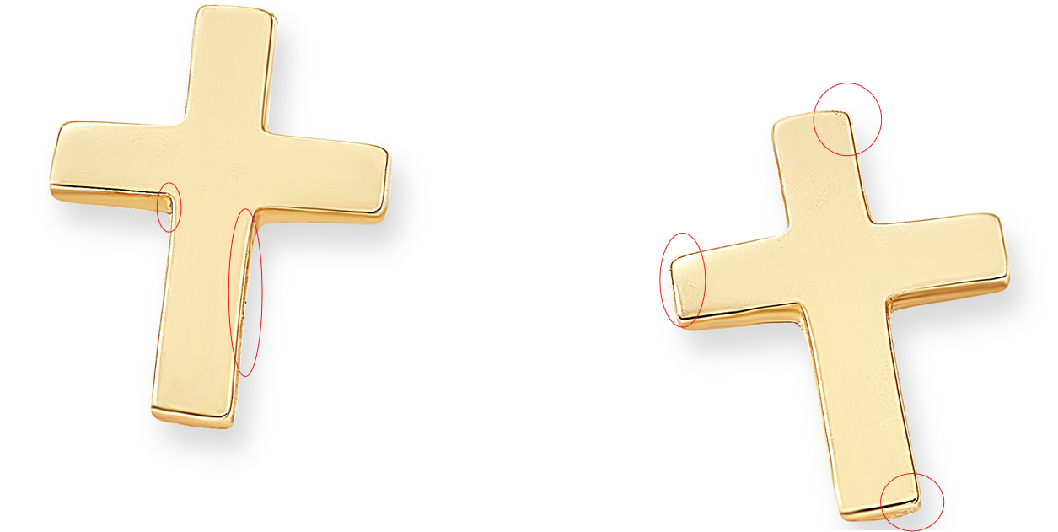
GEG17088Y4-0-0
clean up marks, correct links

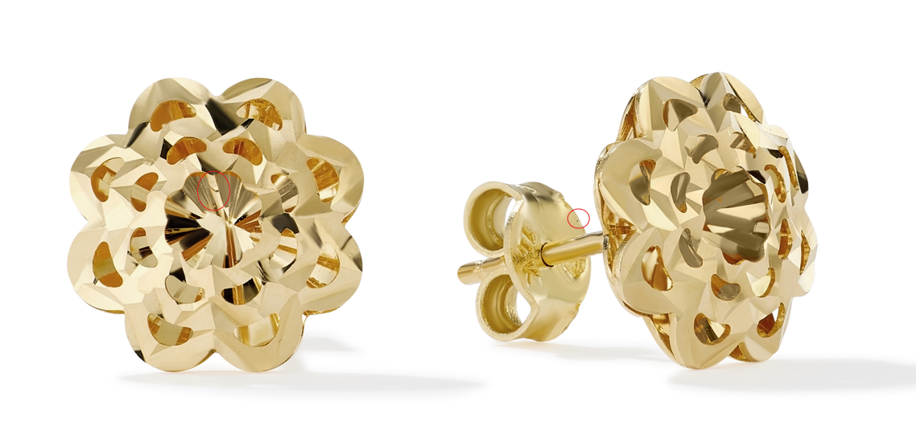

GNK14288R4-0-18



