GCH15301R0-0-18
make gold high polish

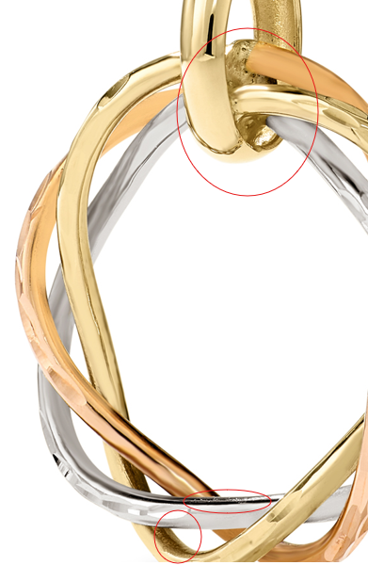

GSE10923Y4-PD-0
Please clean up any noticeable marks, add back opening in bottom

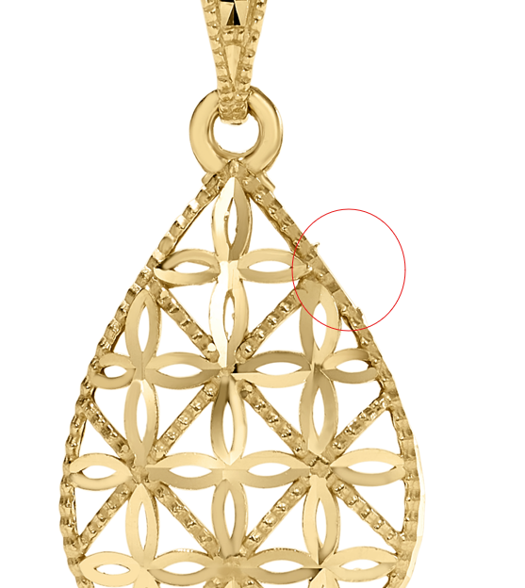
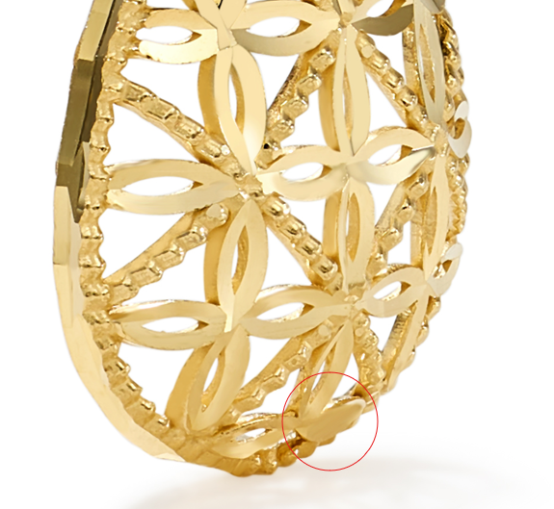

CLP11367Y4-MOP-18
add ruler image
Height: 34.8MM
Width: 25.35MM
Thickness: 3MM

1. Need Pendant Images (Without Chain)
2. Need a complete Necklace Image (Pendant+Chain)

GEG16996Y4-0-0
Please make gold high polish, update correct links

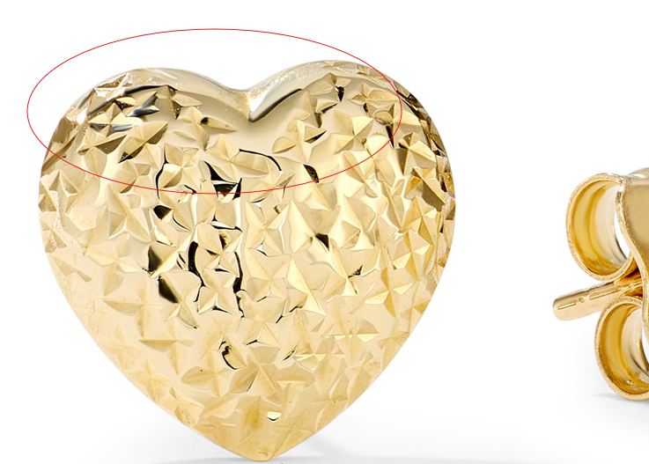

CLE10640Y0-BOX-0
Please touch up gold seams
Retouch

CLE11878Y4-MOP-0

Please clean up any noticeable marks in Image B

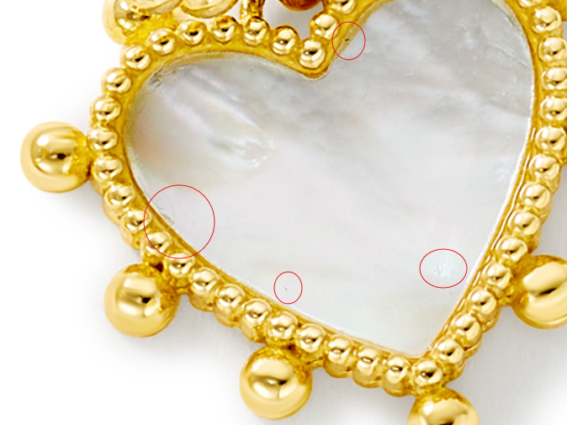

GCH15417Y4-0-0
Please clean up any noticeable marks and dust
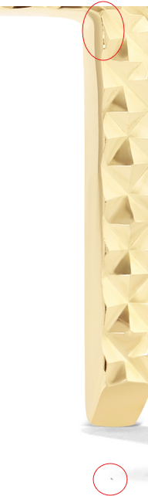

GEG20073Y4-0-0
Please clean up gold seams in Image A
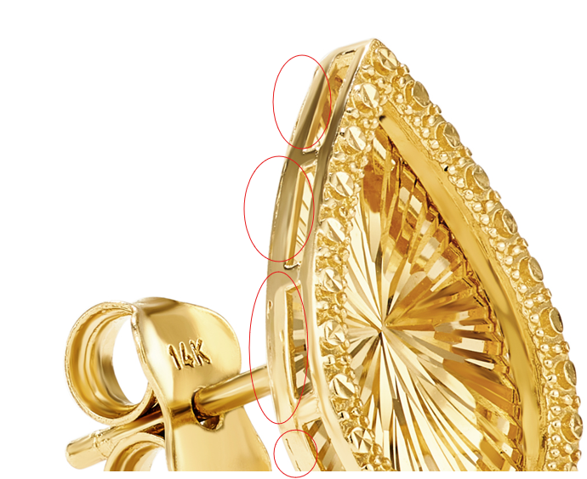

GCH20166Y4-0-0
Please clean up any noticeable marks in Image A, make reflection look the same over the whole piece
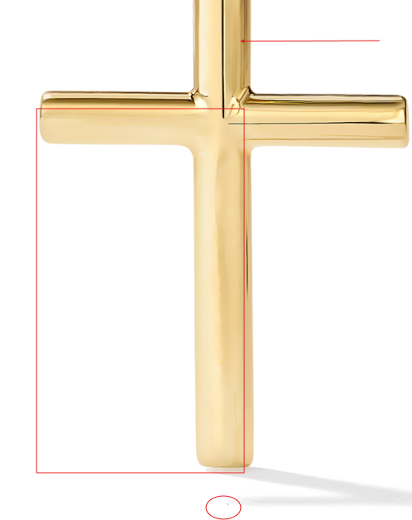

GEG16968Y4-V1-0
Please clean up dust marks in Image A

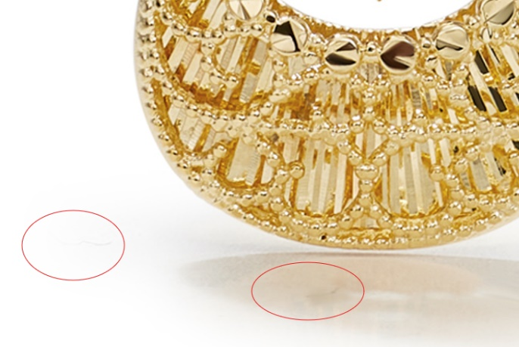
Please clean up any noticeable marks, update links after editing

CLP10878T4-PD-0
Please clean up any noticeable marks, make gold high-polish
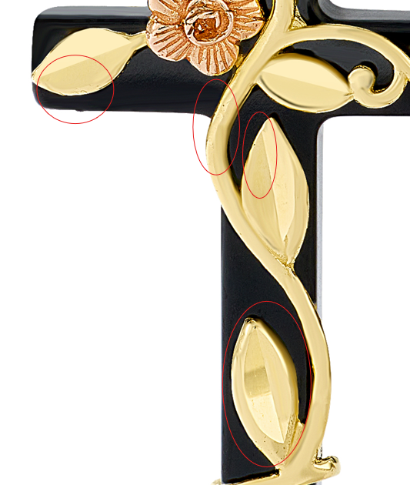

POP10061SS-DC-20.24

Please make sure the whole chain is the same color all over, add ruler image

We need:
1. Chain by itself
2. Chain on Male Neck Close Crop.jpg with 2 lengths: 20 inches and 24 inches
3. Chain on Neck_Woman.png with 2 lengths: 20 inches and 24 inches

CLE11548Y4-BOX-0
Please make sure that any retouching isn't noticeable and looks natural, touch up marks
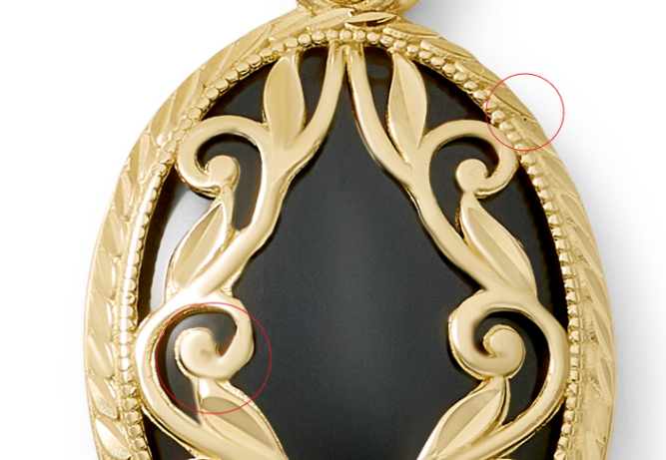

Please clean up any noticeable marks in Image B and touch up gold seams

GRG11590T0-0-7
Make gold high polish

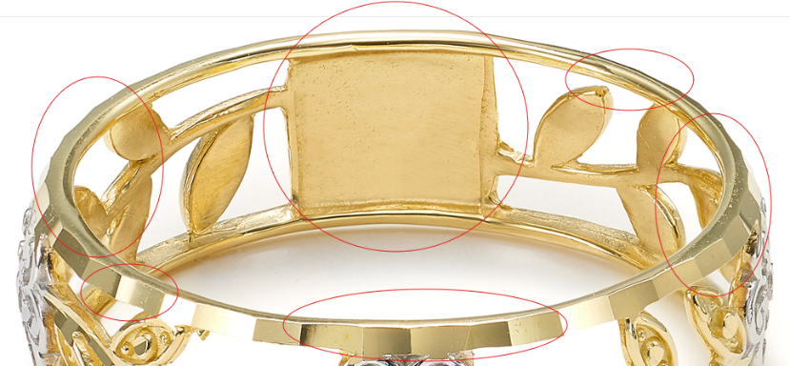

CLE10640Y0-BOX-0

Retouch
Please touch up gold seams

