GCH13591R0-0-18
please make seams circled look cleaner


GCH20148Y4-HP-0
Please clean up circled

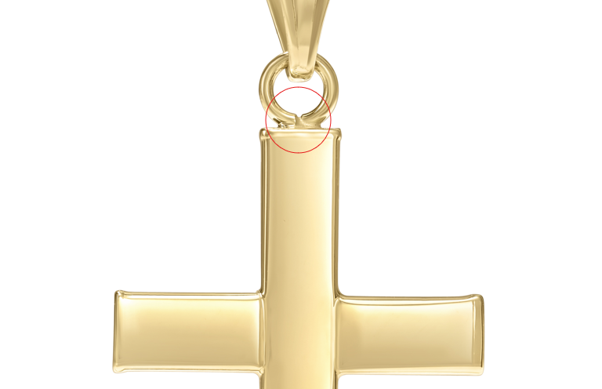

GCH15417Y0-0-0
again please make circled jump ring circular

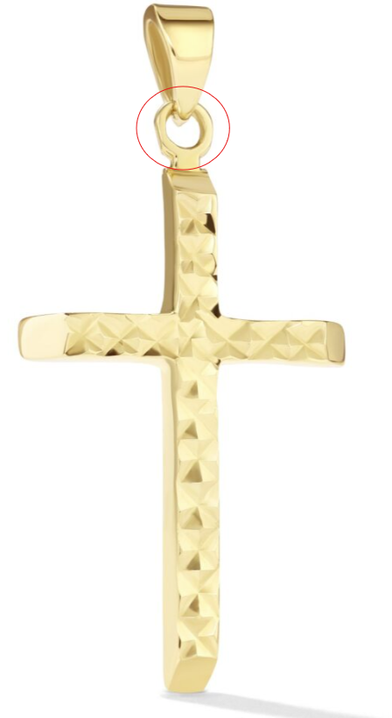

GCH15417Y0-0-0
again please make circled jump ring circular

GHP15622Y4-0-0
please clean up middle circled
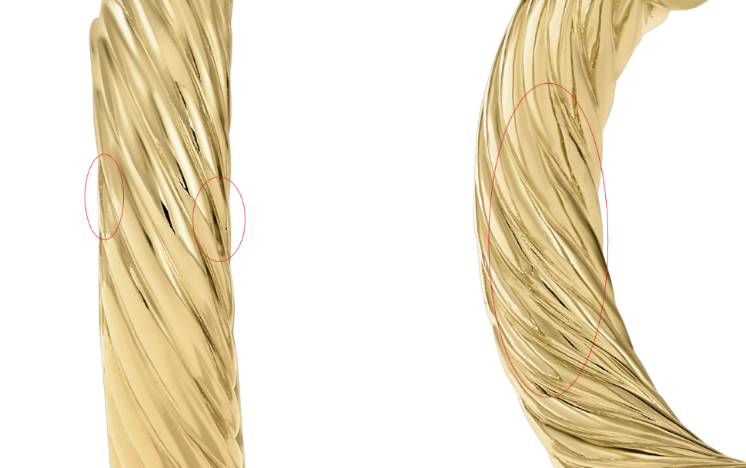

GCH15417Y4-0-0
Again please clean up bottom circled and fix links
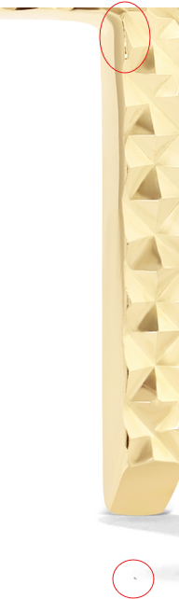

CLP10878T4-PD-0
please clean up these marks


CLE11548Y4-BOX-0

please clean up circled and make look natural

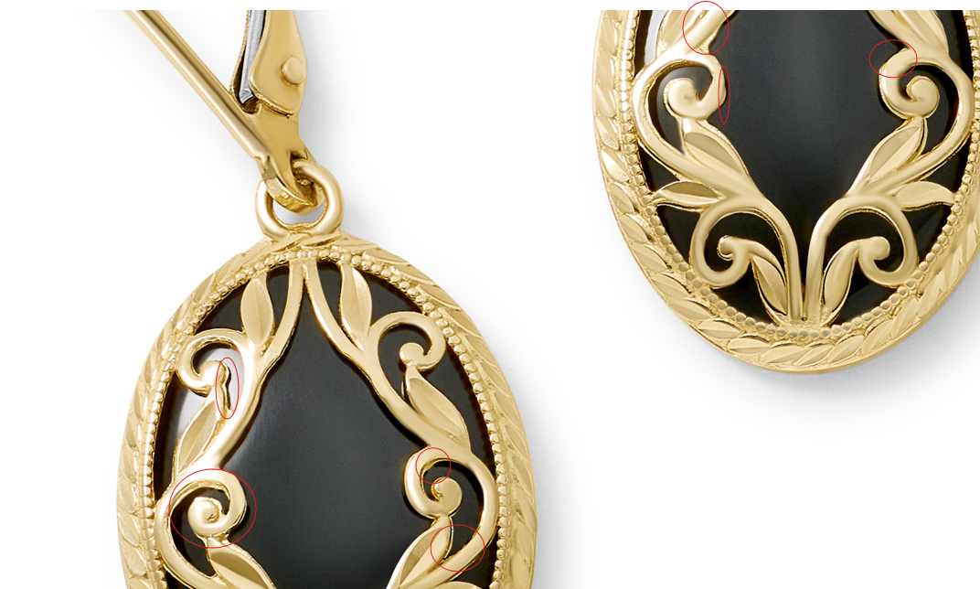

GCH20166Y4-0-0
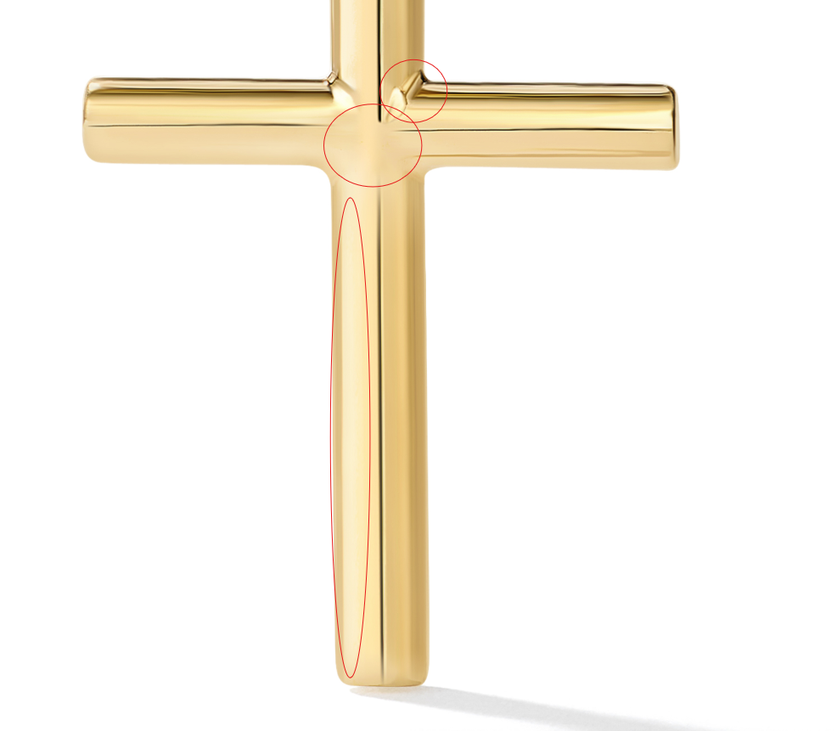

GCH20166Y0-0-0

GCH20166W0-0-0
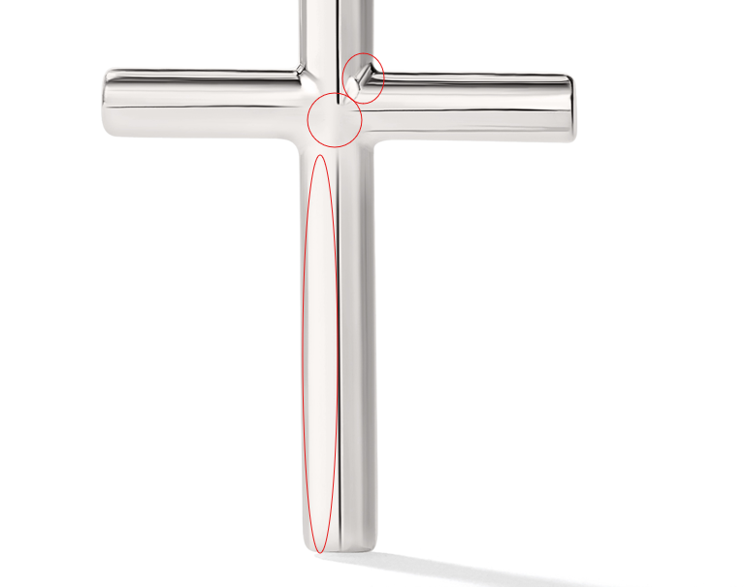

GCH20166W4-0-0

GCH20166Y0-0-0

GEG20145Y4-0-0
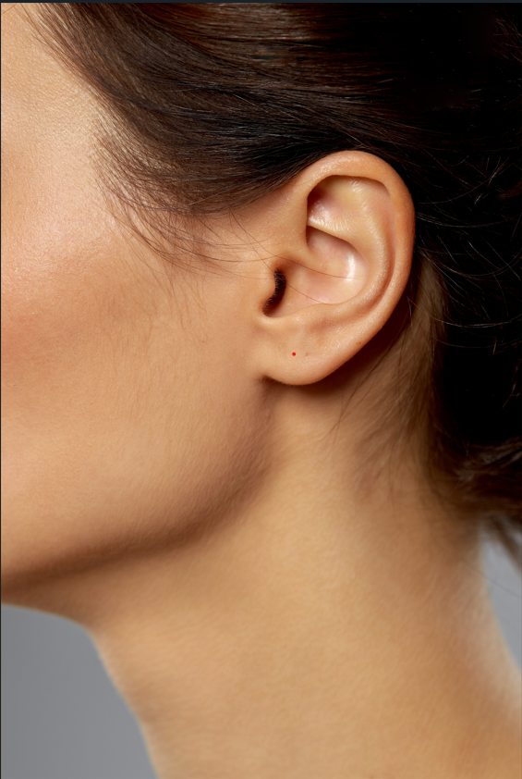

GCH20167R0-0-0

All links are wrong. Fix links. Clean up marks.

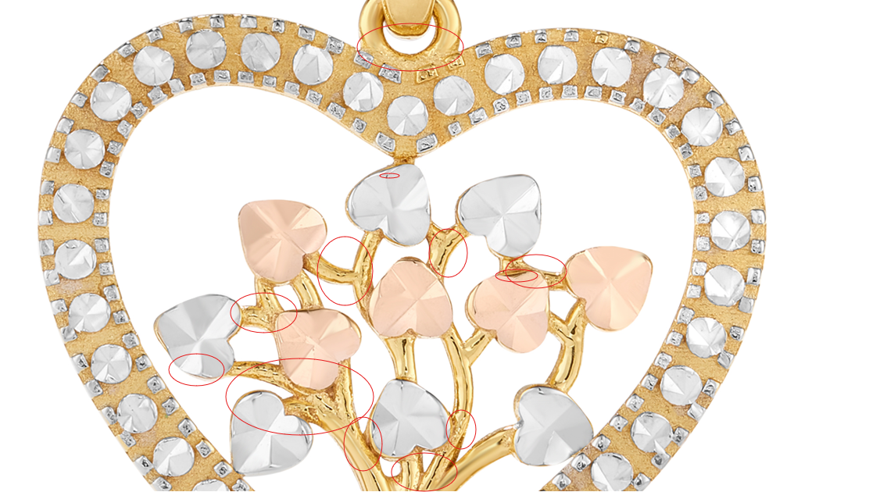

GCH15301R0-0-18

Please clean up marks in the top circle, fix links
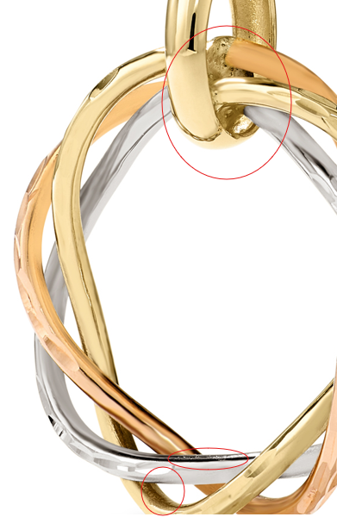

GCH20167R4-0-0
