GCH20166Y0-0-0

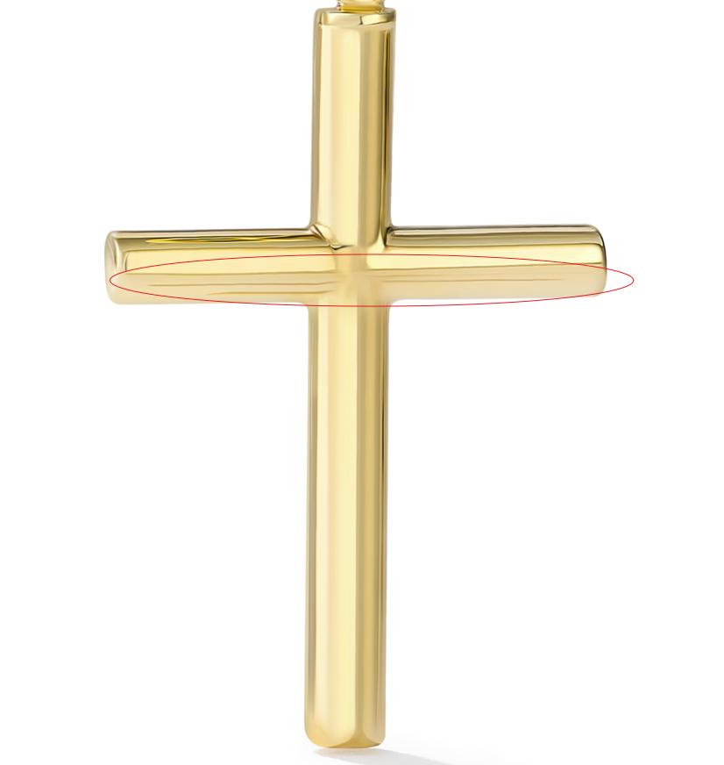

GCH20166W0-0-0
Please make the reflection even over the whole piece

GCH20166W4-0-0
again please make the reflection the same over the whole piece

GHP20181Y4-0-0
Please clean up marks

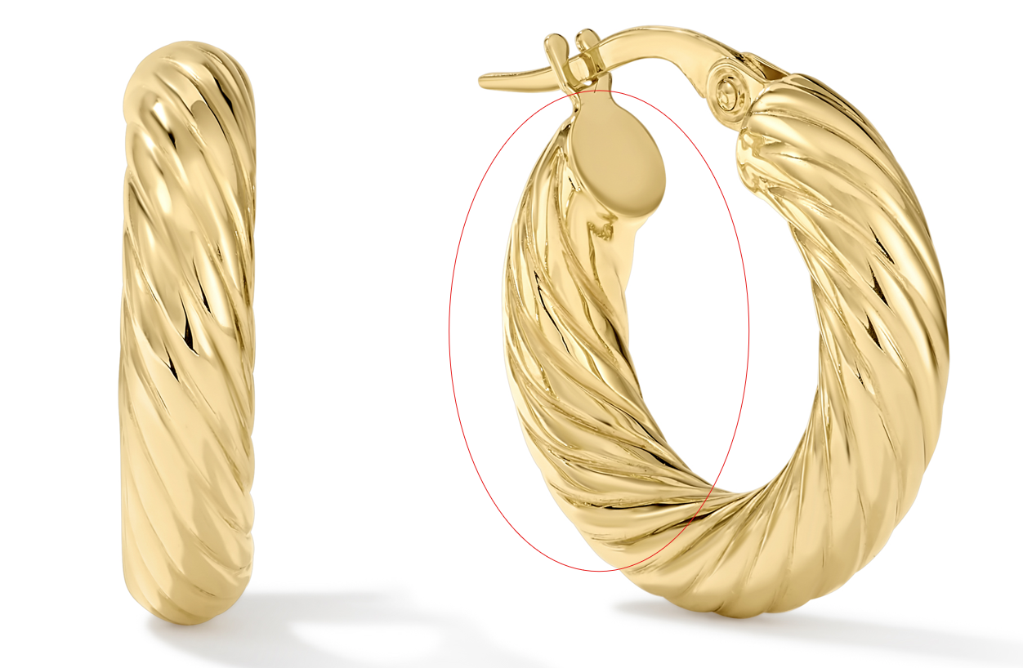

GCH20167R4-0-0
Please clean up circled, fix links
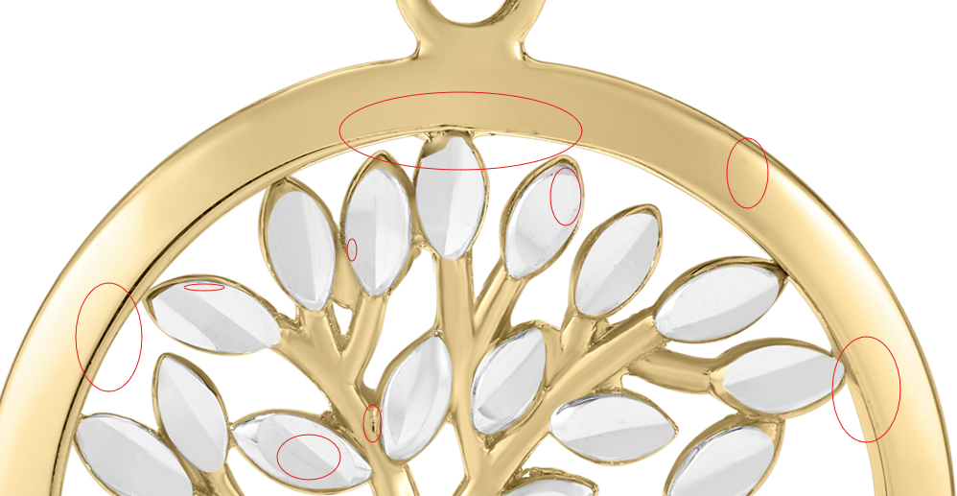

GCH20148Y4-HP-0
Please clean up circled
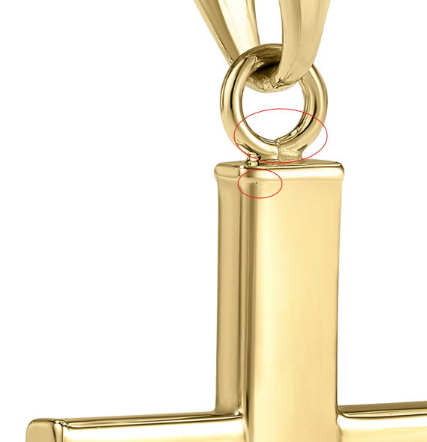

GHP15997W4-0-0

GCH15417Y0-0-0
please fix circled

GHP20237Y4-0-0
Please clean up circled
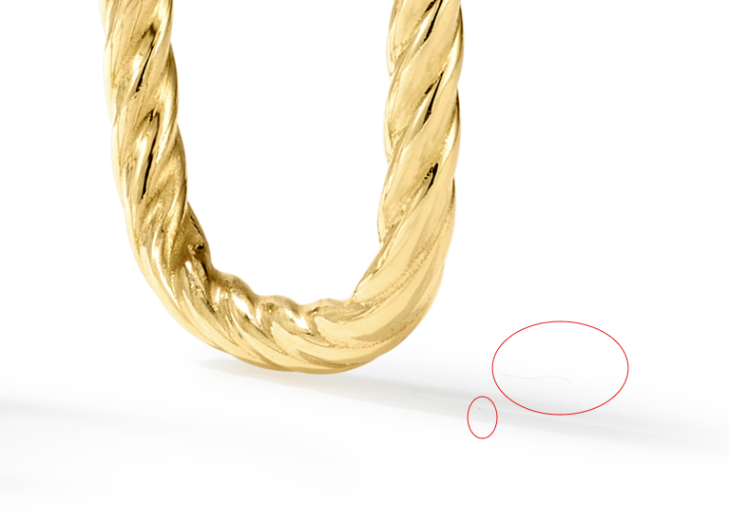
GHP15622Y4-0-0
clean up marks
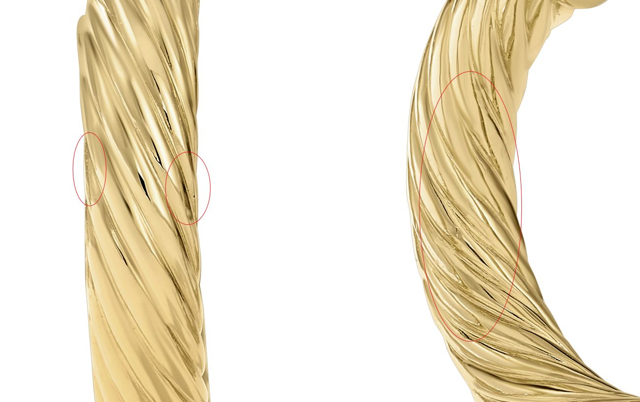

GEG16996Y4-0-0
please clean up marks circled, fix links
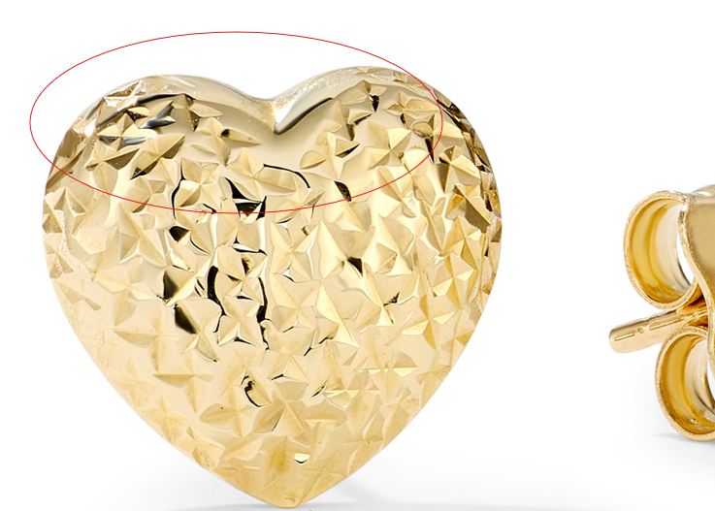

GCH15417Y4-0-0
Please clean up circled marks, fix links
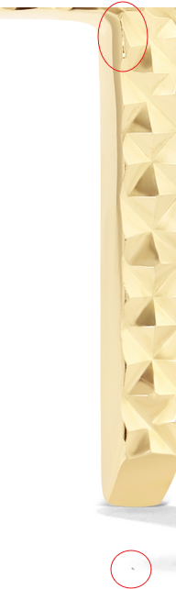

GEG20073Y4-0-0
please clean up marks from above, fix links
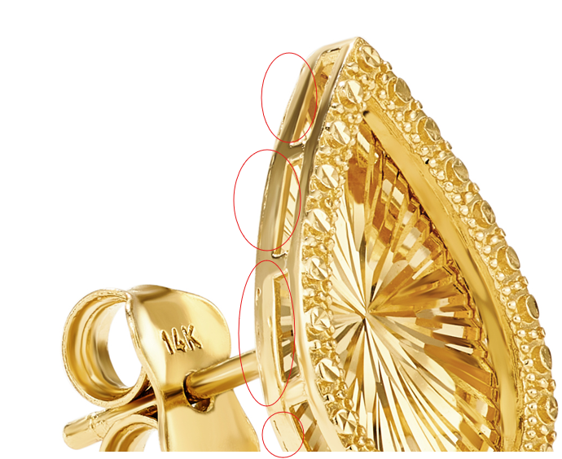

GCH20166Y4-0-0
again please make reflection look the same over the whole piece
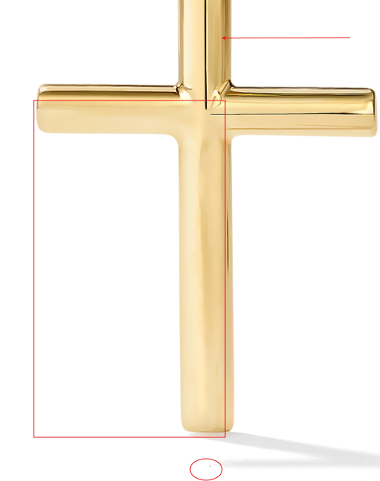
CLP10878T4-PD-0
Clean up marks, fix links
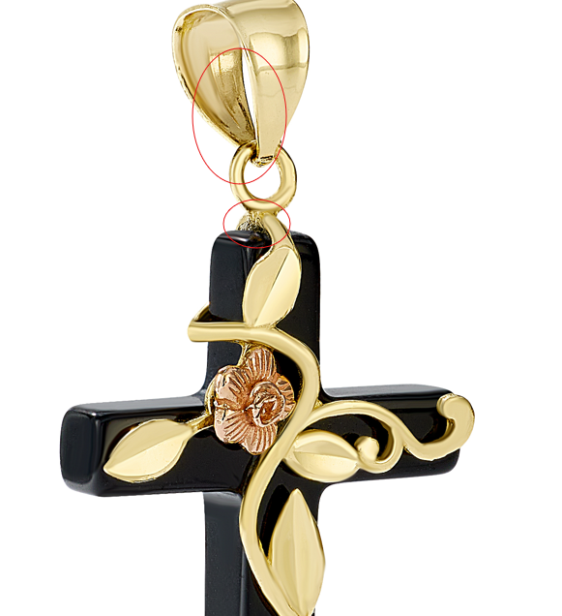
CLE11548Y4-BOX-0
Please clean up gold seams and make lines even
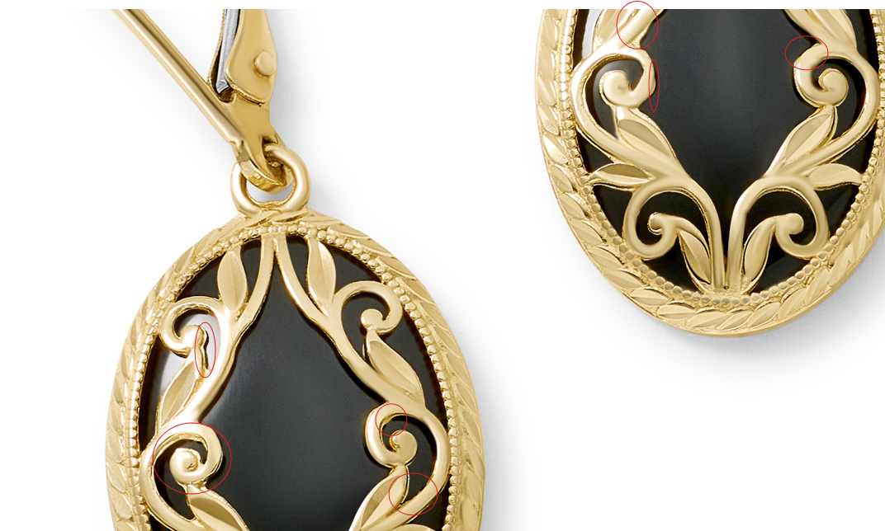

GCH15301R0-0-18
Please clean up marks in the top circle, fix links
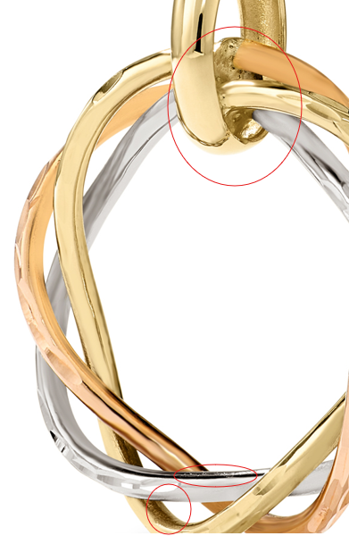

GNK14288R4-0-18
GNK14288R4-0-18
add ruler photo
GEG20145Y4-0-0
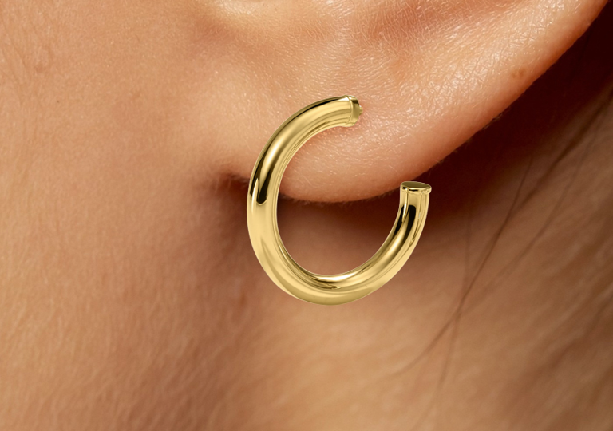

GEG20145Y4-0-0

