GHP20350Y4-0-0
please fix this mark
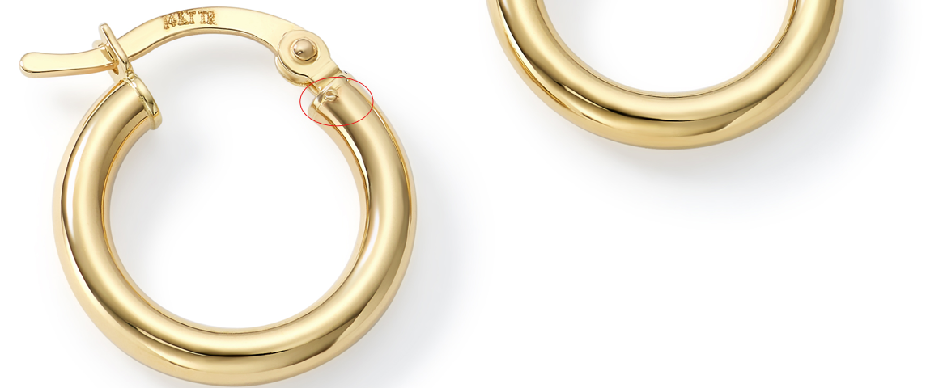

please fix this one too
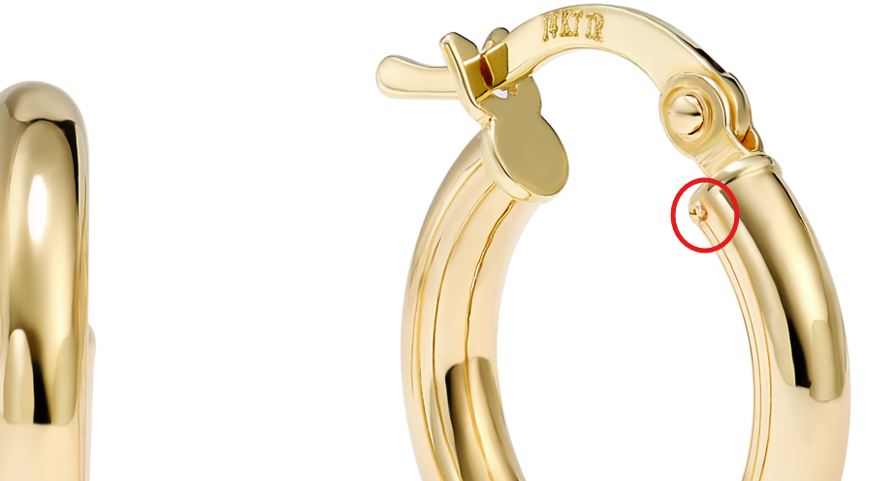

GCH15417Y4-0-0

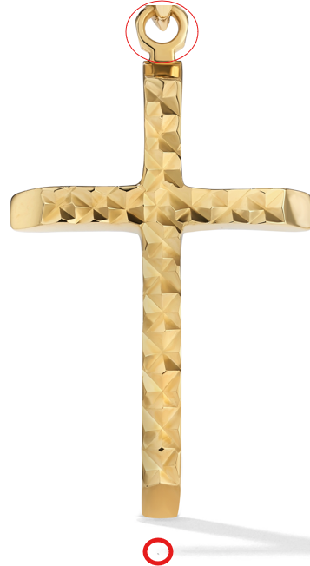

GCH20167R4-0-0
clean up marks, fix color

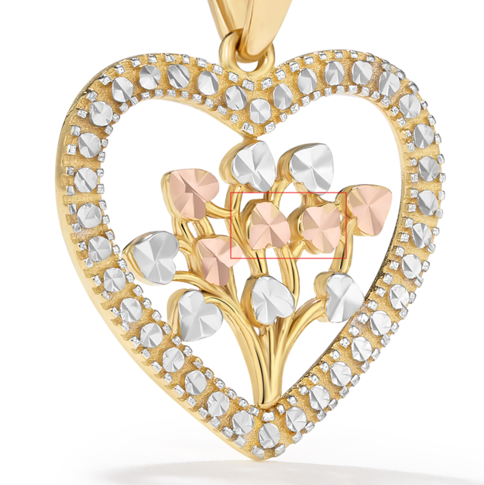

GCH20167R0-0-0
Clean up marks.
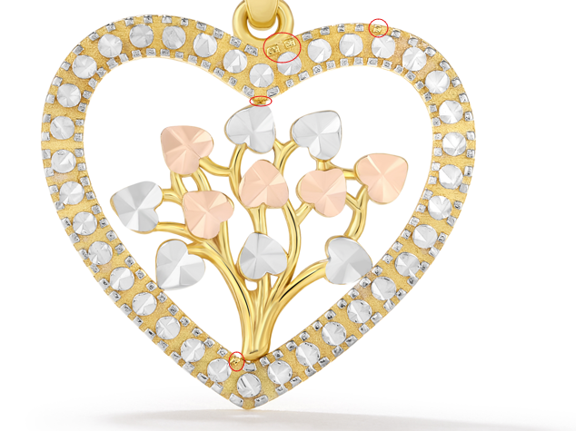

GCH20166Y4-0-0
Make same changes in ruler image

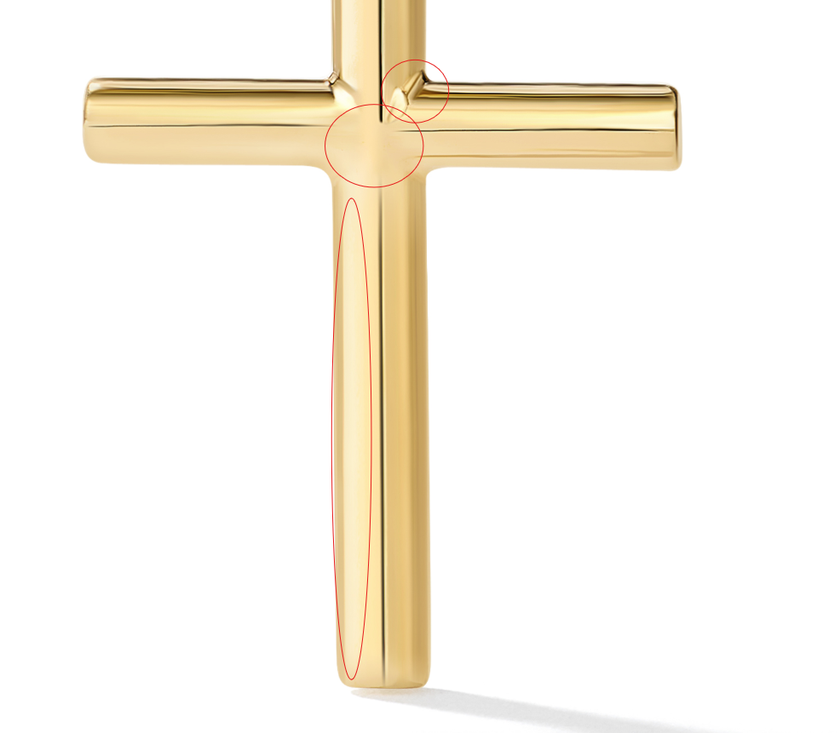

GCH20166Y0-0-0
please fix previous comments

GCH20166W0-0-0
please fix previous comments

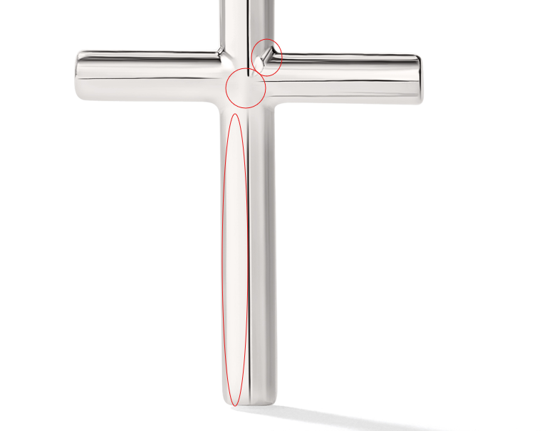
GCH20166W4-0-0
please fix previous comments

GCH20168T4-0-0
please fix circled
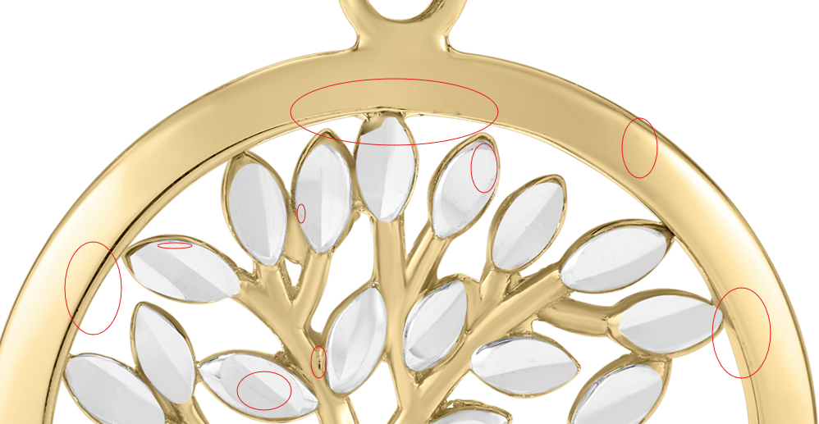

GRG11590T0-0-7
please clean up marks in image B

