SSE10100SS-BOX-7.5 Pendant
Add model image

GCH20167R0-0-0
Clean up marks.
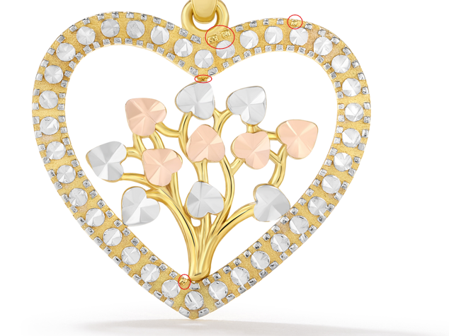

GCH15417Y0-0-0

