GCH20167R0-0-0
All links are wrong. Fix links. Clean up marks.

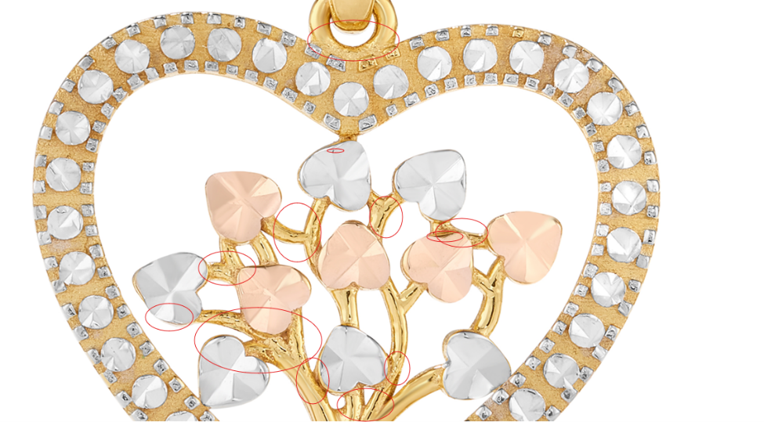

GEG17129T0-TUA-0
clean up marks.

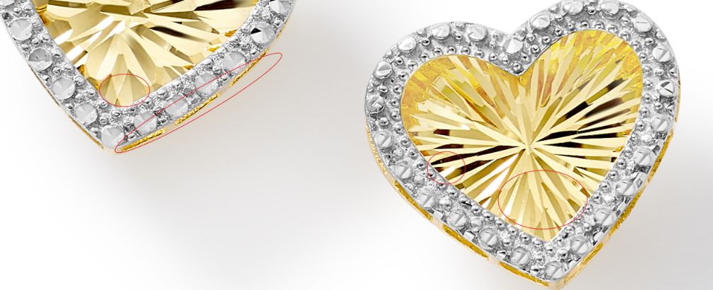

GCH20166Y0-0-0
Make reflection even.

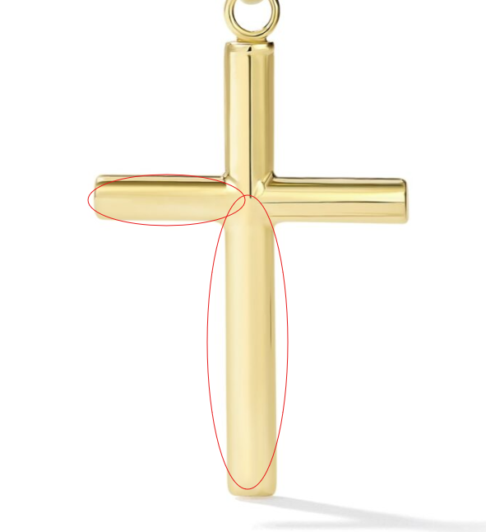

GCH20166W0-0-0
Make reflection even.
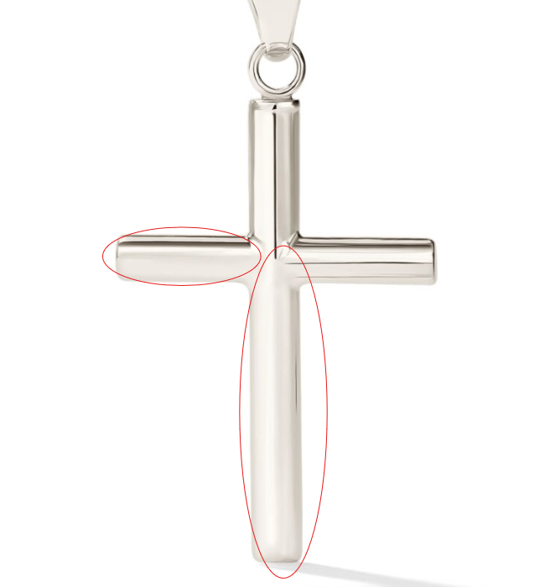
GCH20166W4-0-0
Make reflection even.
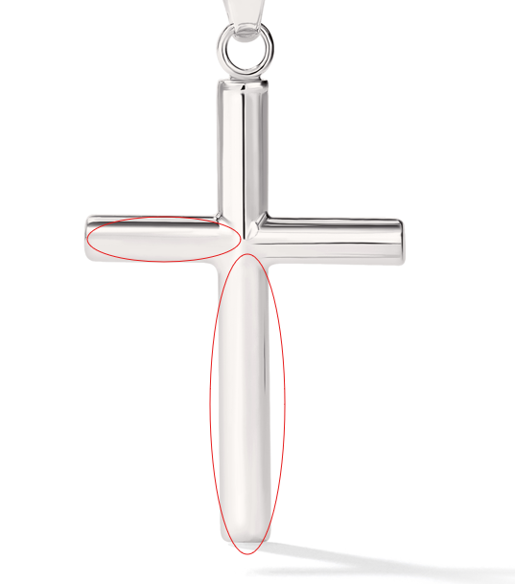

GRG11582Y4-0-7
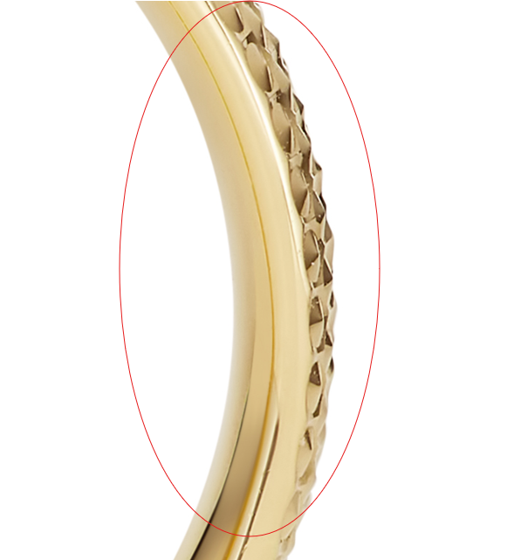
GCH15417Y0-0-0
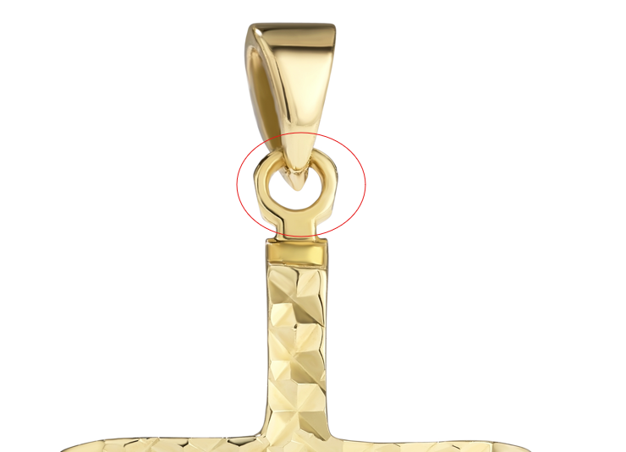

CLE10640Y0-BOX-0
GSE10923Y4-PD-0
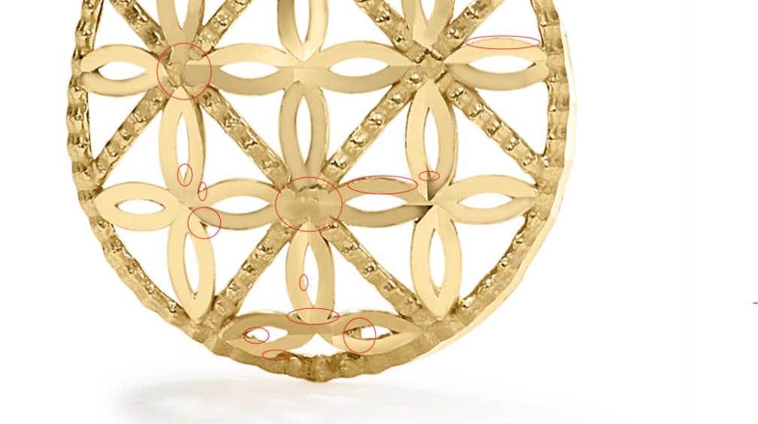
SSE10100SS-BOX-7.5 Pendant

