GCH15417Y0-0-0
make sure these marks are gone in all these photos

GHP15746W0-0-0
make sure this is fixed in ruler image

GHP15997W4-0-0

again please clean up circled

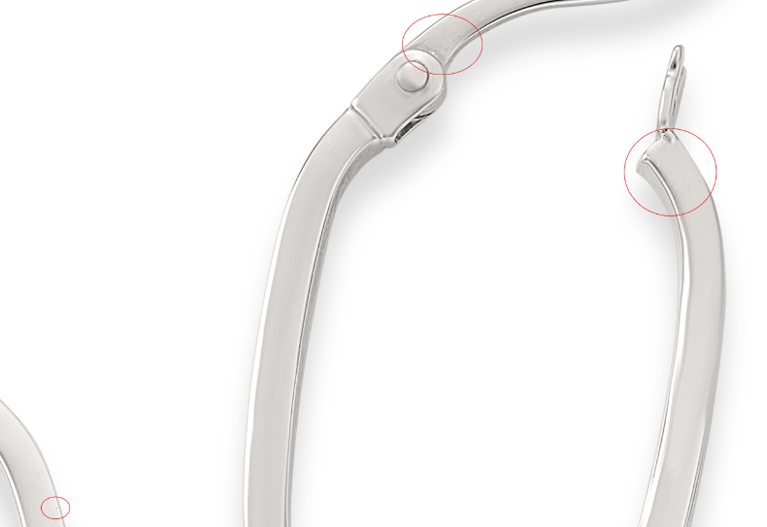

GEG16170Y0-0-0
clean up any marks

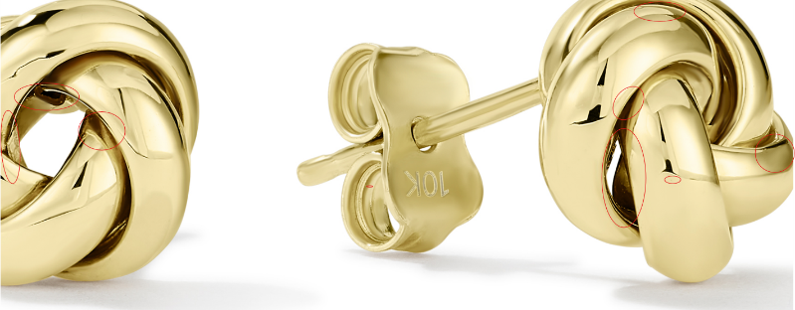

GHP15746Y0-0-0
fix this in ruler image

GRG11582Y4-0-7

