GCH15417Y4-0-0
Please clean up bottom circled mark

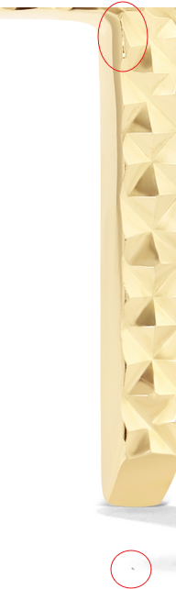

CLE11548Y4-BOX-0

Please see previous comment and fix Image B
Please clean up gold seams and make lines even

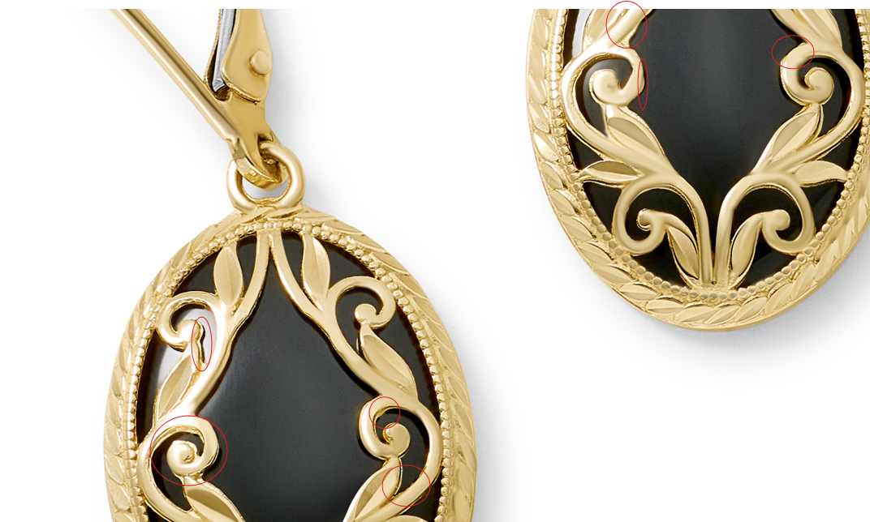

GCH15301R0-0-18
Please see previous comment
Please clean up marks in the top circle, fix links

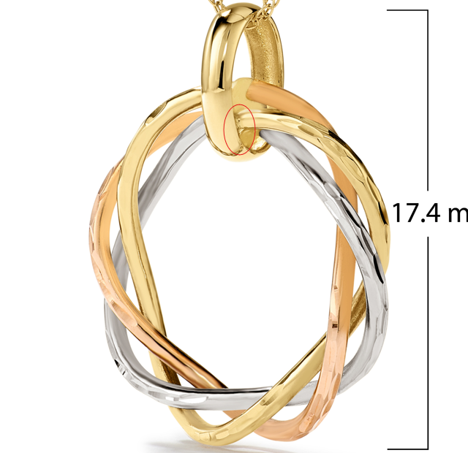

GCH20167R4-0-0
please see previous comment

