GCH15417W4-0-0
again clean up circled in image A
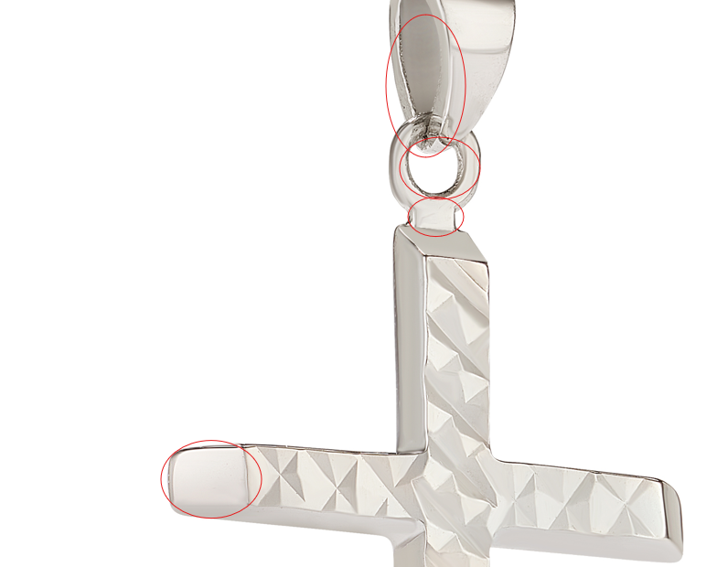
GHP20345Y0-0-0
please clean up circled and fix links
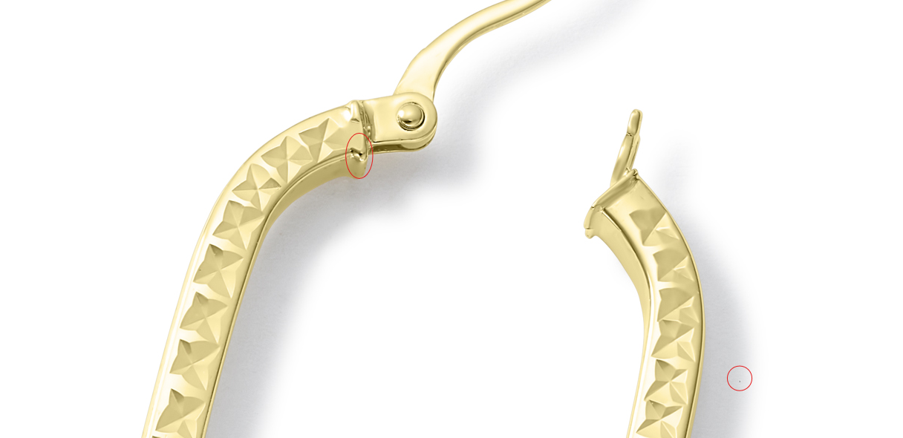
GCH15428Y4-0-0
Please use this model:
ROL10506Y4-0-20.22_Lifestyle-

again fix circled marks and links

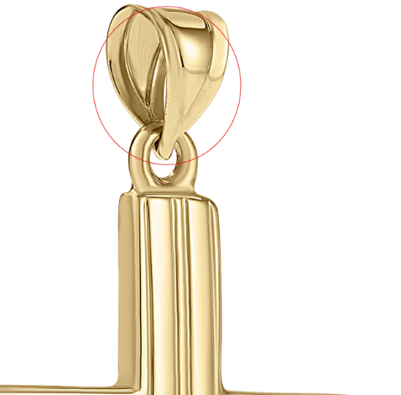

GCH20085Y4-0-0
Please use this model: ROL10506Y4-0-20.22_Lifestyle-
again fix circled and links
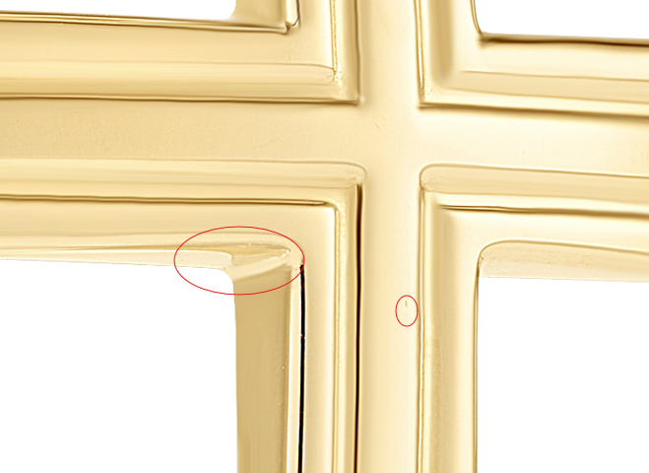

CLE10640Y0-BOX-0

make smooth effect more natural

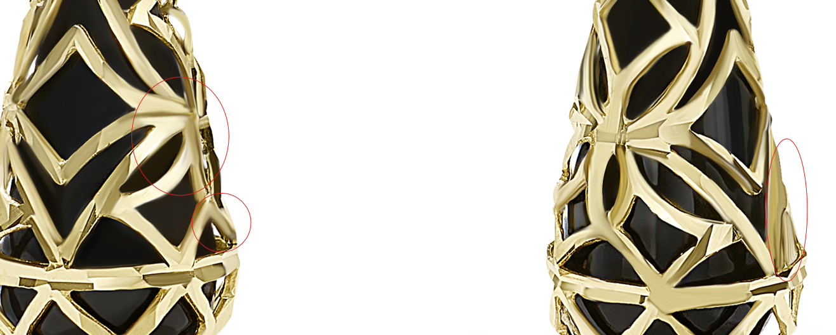

POP10061SS-DC-20.24
color looks yellow

GSE10923Y4-PD-0
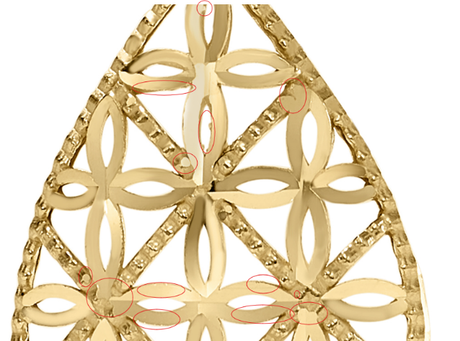

CLE11878Y4-MOP-0
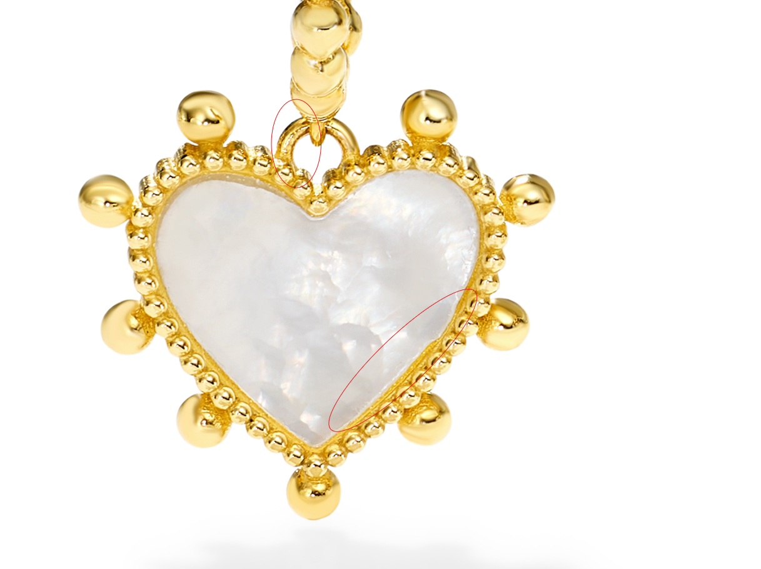

SSE10100SS-BOX-7.5 Pendant
