GCH15301R0-0-18
make gold high polish, correct links

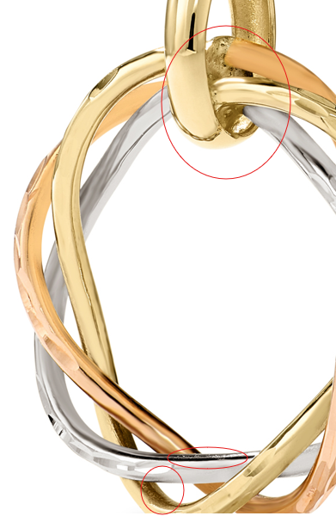

GCH20167R4-0-0

clean up marks, fix color
