GCH15301R0-0-18
make gold high polish, correct links

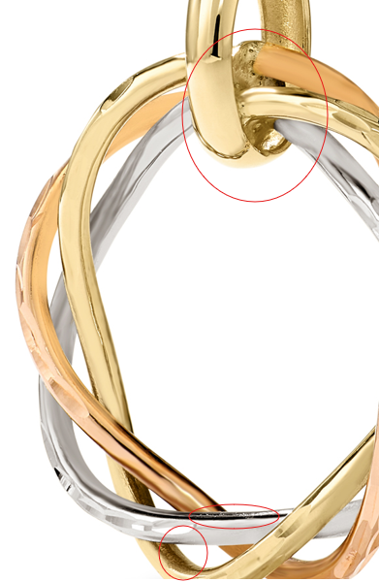

GCH20167R4-0-0

clean up marks, fix color
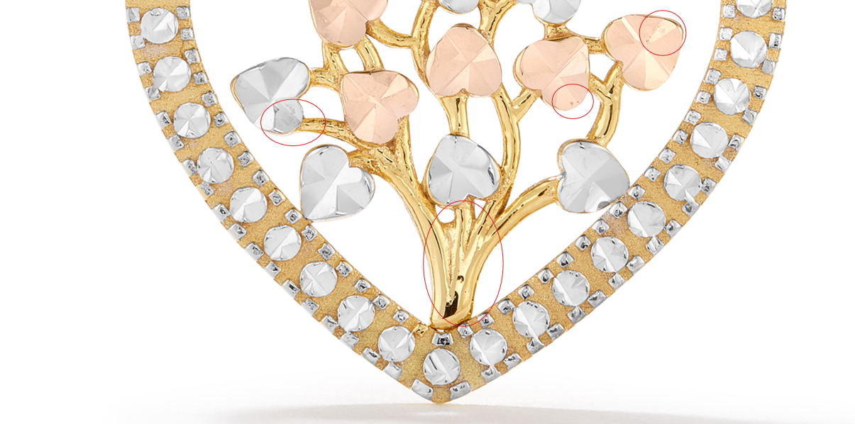

Hoop Group Shots

GHP20369Y4-0-0
Group shot needed for GHP20368Y4-0-0, GHP2036Y4-0-0, GHP20370Y4-0-0, GHP20371Y4-0-0 for size comparison, as well as individual shots

GHP20347Y4-0-0
Group shot needed for GHP20362Y4-0-0, GHP20346Y4-0-0, GHP20347Y4-0-0 for size comparison, as well as individual shots

GHP20348Y0-0-0
GHP20374Y0-0-0

GHP20370Y4-0-0
Group shot needed for GHP20368Y4-0-0, GHP2036Y4-0-0, GHP20370Y4-0-0, GHP20371Y4-0-0 for size comparison, as well as individual shots

GHP20368Y4-0-0
Group shot needed for GHP20368Y4-0-0, GHP2036Y4-0-0, GHP20370Y4-0-0, GHP20371Y4-0-0 for size comparison, as well as individual shots

GHP20371Y4-0-0
Group shot needed for GHP20368Y4-0-0, GHP2036Y4-0-0, GHP20370Y4-0-0, GHP20371Y4-0-0 for size comparison, as well as individual shots

GHP20369Y4-0-0
Group shot needed for GHP20368Y4-0-0, GHP2036Y4-0-0, GHP20370Y4-0-0, GHP20371Y4-0-0 for size comparison, as well as individual shots

GHP20346Y4-0-0
Group shot needed for GHP20362Y4-0-0, GHP20346Y4-0-0, GHP20347Y4-0-0 for size comparison, as well as individual shots

GHP20369Y0-0-0

