GRG11582Y4-0-7
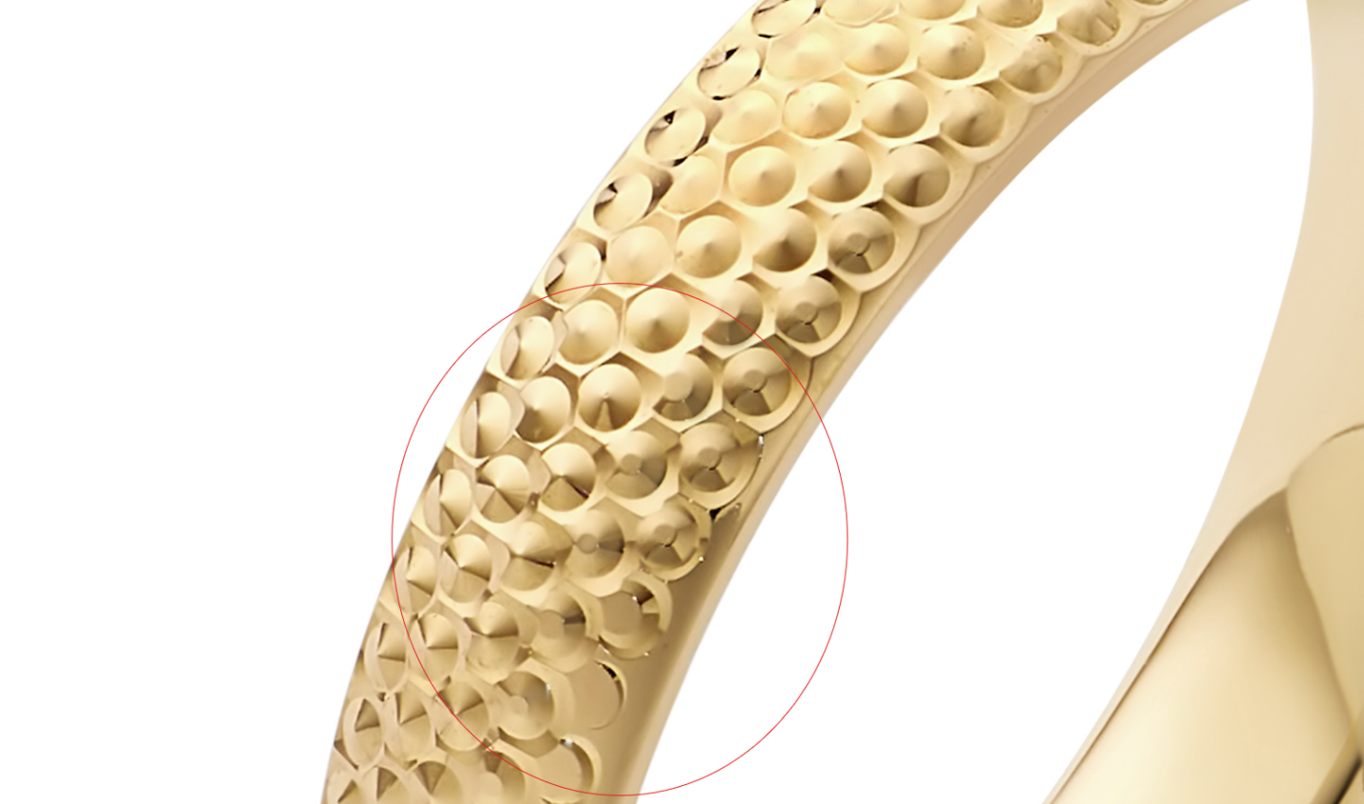

again please clean up the marks in image A

GCH20085Y4-0-0
Please use this model: ROL10506Y4-0-20.22_Lifestyle-

GCH15428Y4-0-0
Please use this model: ROL10506Y4-0-20.22_Lifestyle-

SSE10100SS-BOX-7.5 Pendant
clean up circled marked in image B, fix links

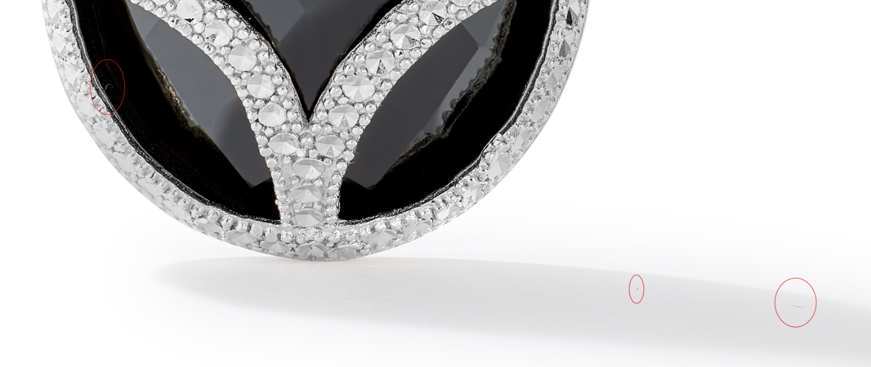
SSE10100SS-BOX-7.5 Earring
clean up marks, update correct links

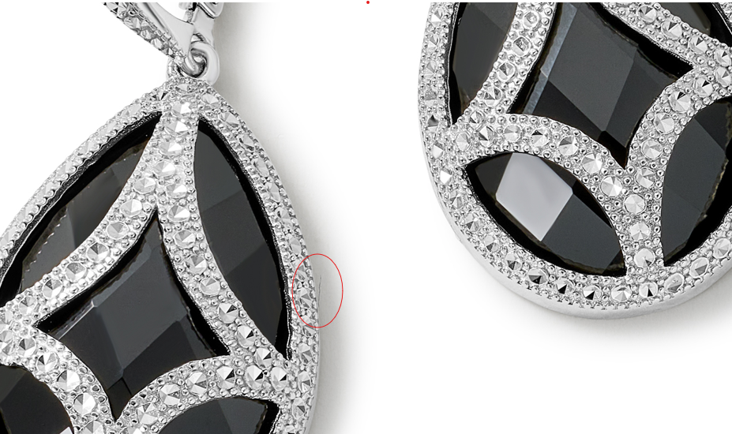

CLE11878Y4-MOP-0
clean up mark circled at top
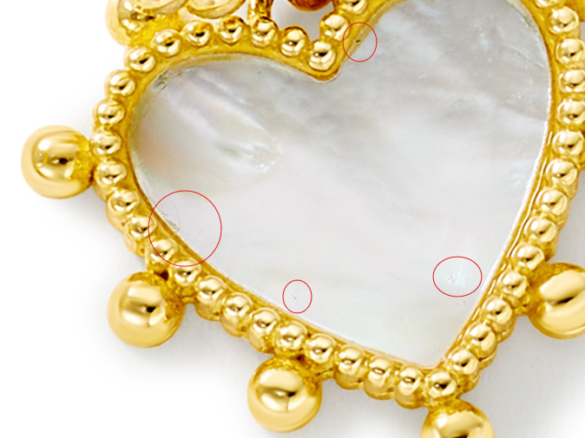

GSE10923Y4-PD-0
fix links, put back oval opening in circled

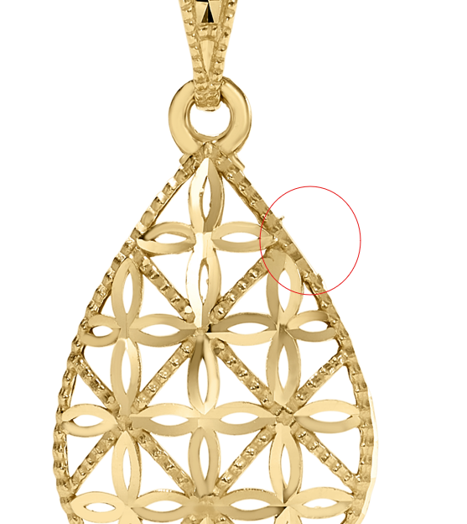
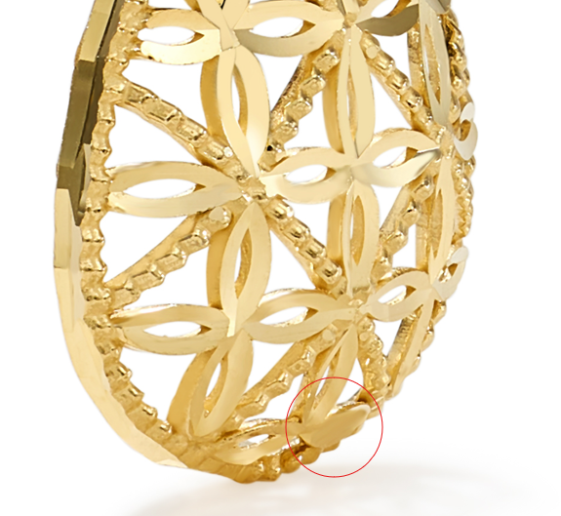
POP10061SS-DC-20.24
Please make sure the whole chain is the same color all over, add ruler image, correct links

CLE10640Y0-BOX-0
please fix circled, correct links
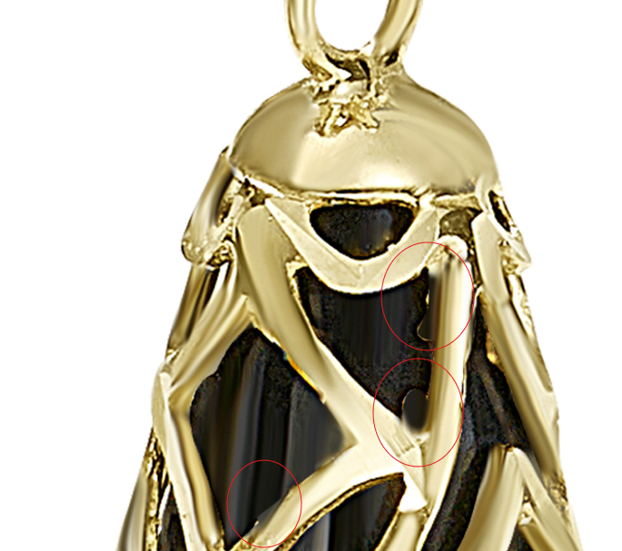

GCH20085Y4-0-0

Please use this model: ROL10506Y4-0-20.22_Lifestyle-
GCH15428Y4-0-0
Please use this model: ROL10506Y4-0-20.22_Lifestyle-

GHP20345Y0-0-0
please clean up circled and fix links
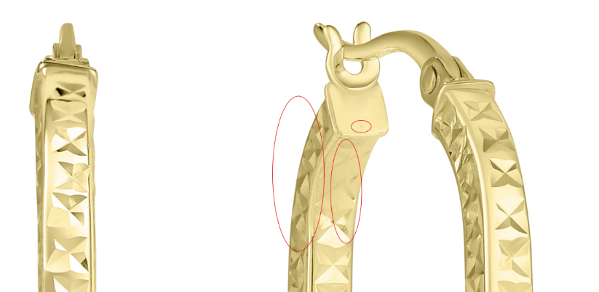
GHP20345W0-0-0
fix links

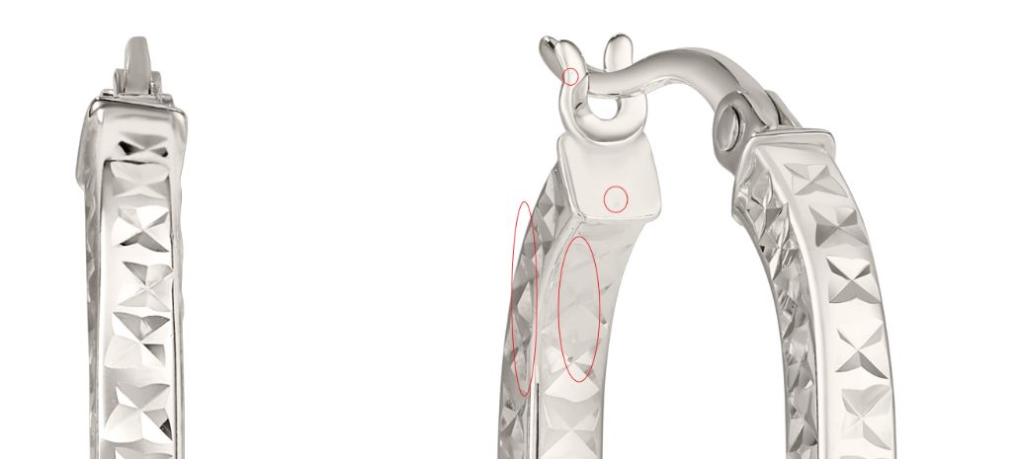

GCH15417W4-0-0
again clean up circled in image A
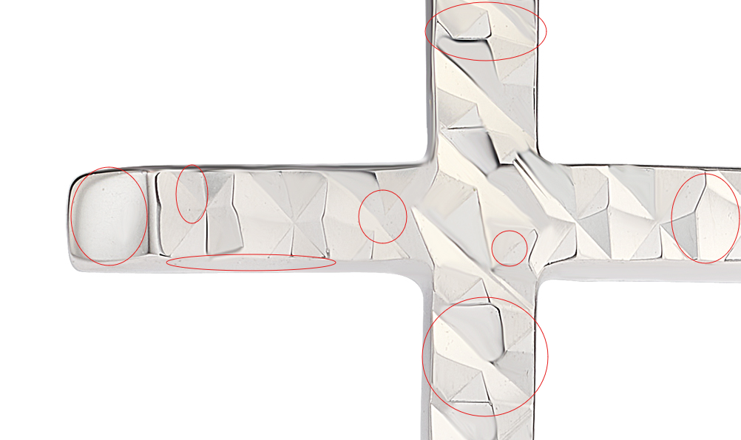

GCH15417Y0-0-0
again clean up circled in image A
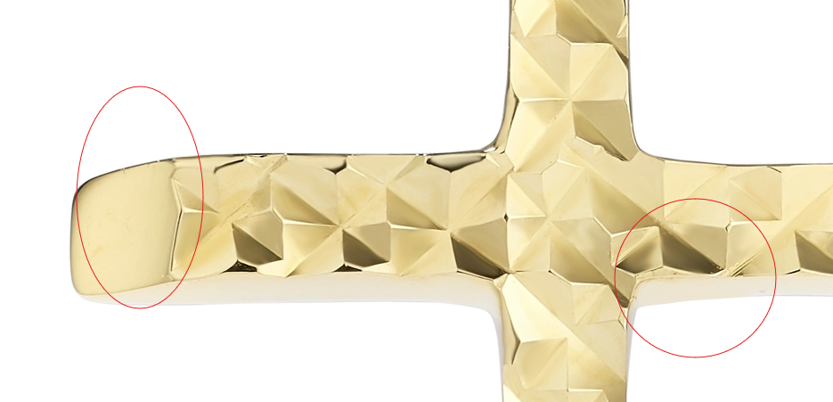

GHP15746W0-0-0
again fix circled and links
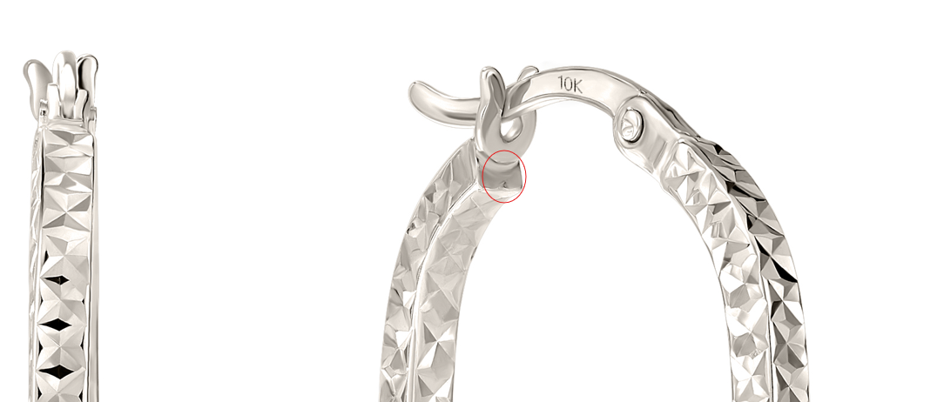

GHP15997W4-0-0
again please clean up circled
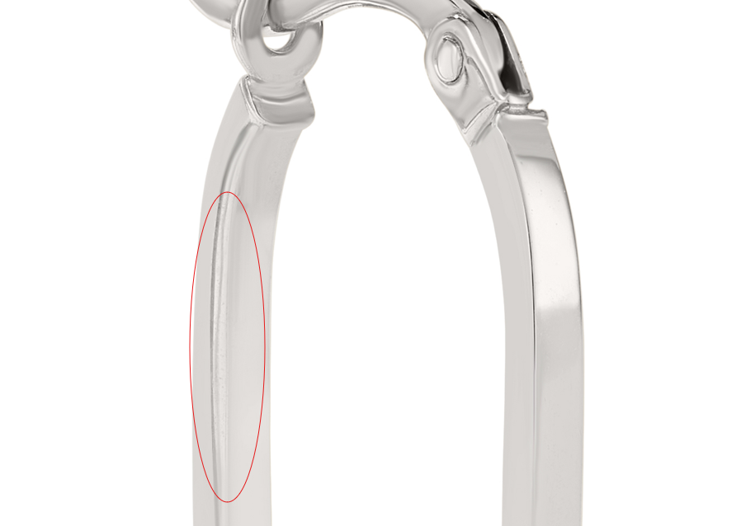

GHP20237W4-0-0
again please clean up circled mark in image A

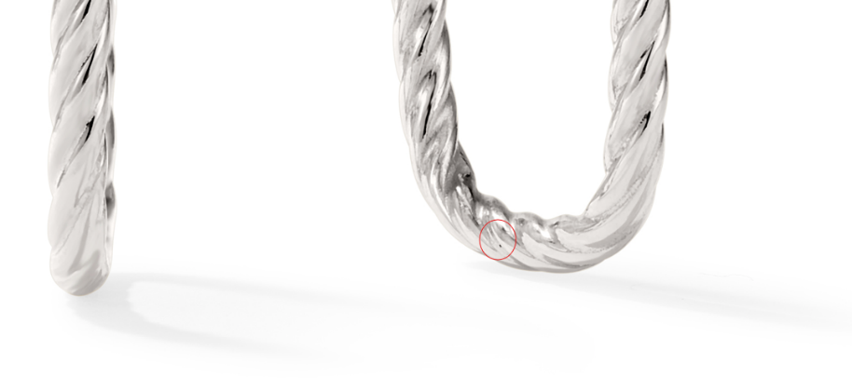

GEG16170Y0-0-0
again please clean up circled marks in image B

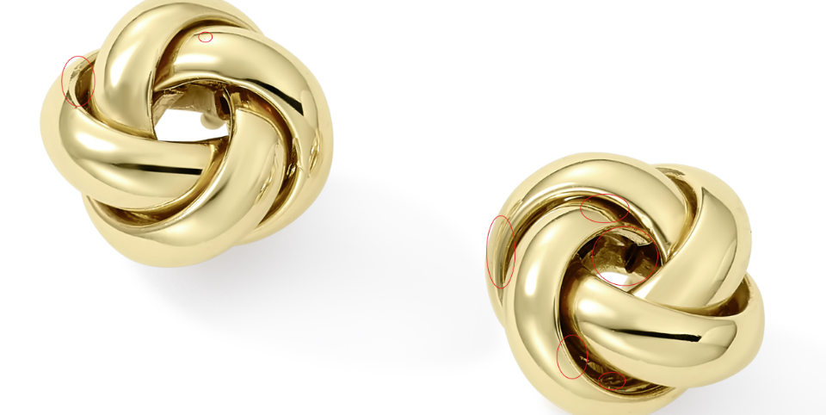

GHP15746Y0-0-0
again please clean up mark circled in image A

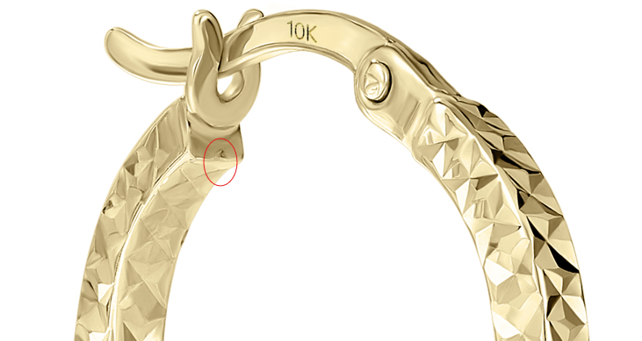

GHP20094Y0-0-0
again please clean up the dust mark in image B
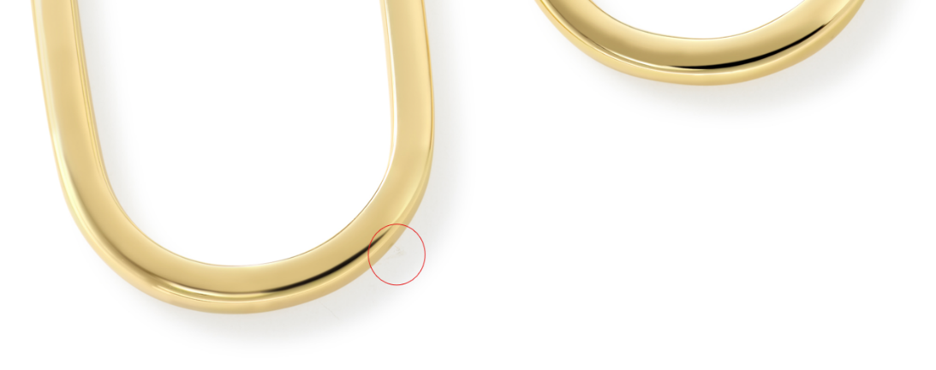

GRG11609Y4-0-7
again please clean up the marks in Image C
