I reviewed the images of the earrings on model and unfortunately they do not look good on her ears. Her piercing is too high and her lobes are too small, it makes the earrings look awkward.

I found another model image to try. Here is the link

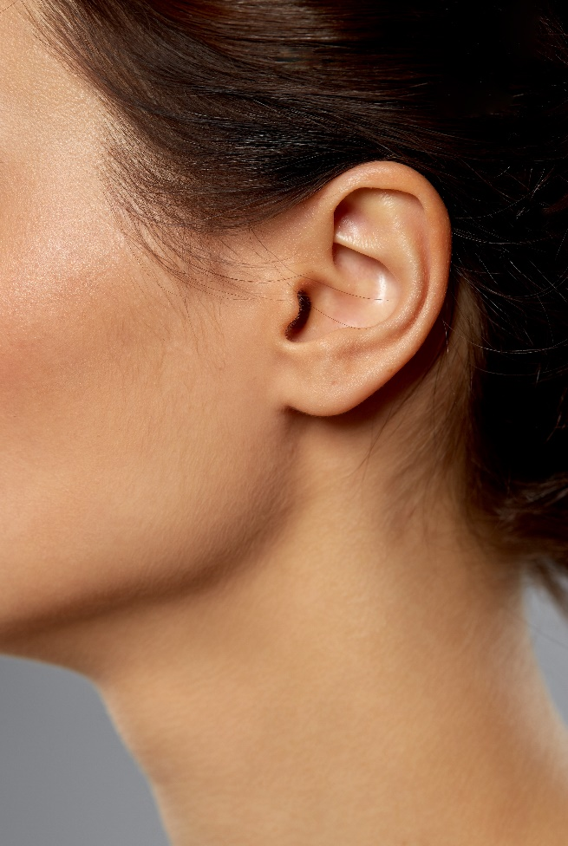
Here is a reference of where I would like the earring placed (marked in red).
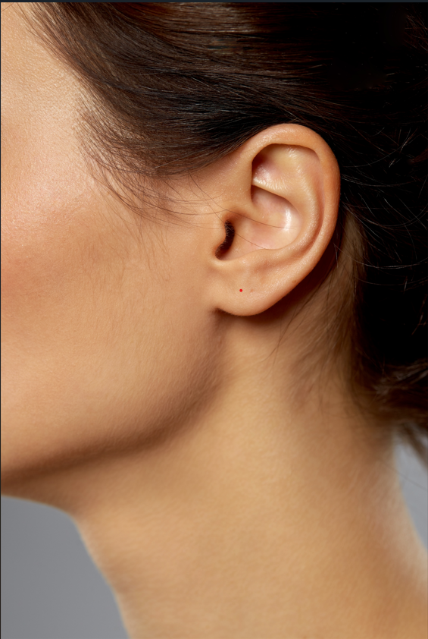
Can you please ask your team to do 1 image only of an earring placed on this model instead and send it to me for review. If it's ok, then we will replace all the earring model images with this one. Thank you

