CLP11421Y4-PD-0
34MMx25MMx3MM

GEG17748W4-0-0
needs overstock image

GEG17687Y4-0-0
needs Overstock model shot

GEG17570Y4-0-0

needs overstock model

GEG17311Y4-0-0

have all over floral pattern look more like this and even

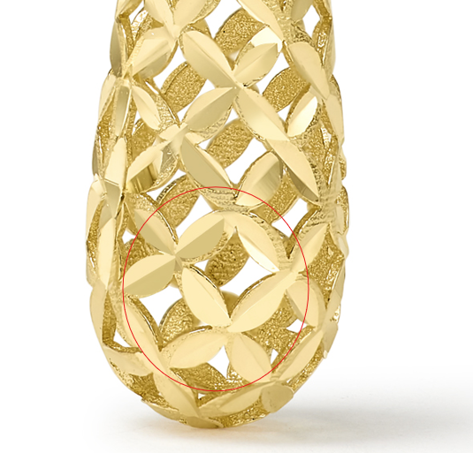
GEG17000Y4-REGNUT-0

clean up roughness

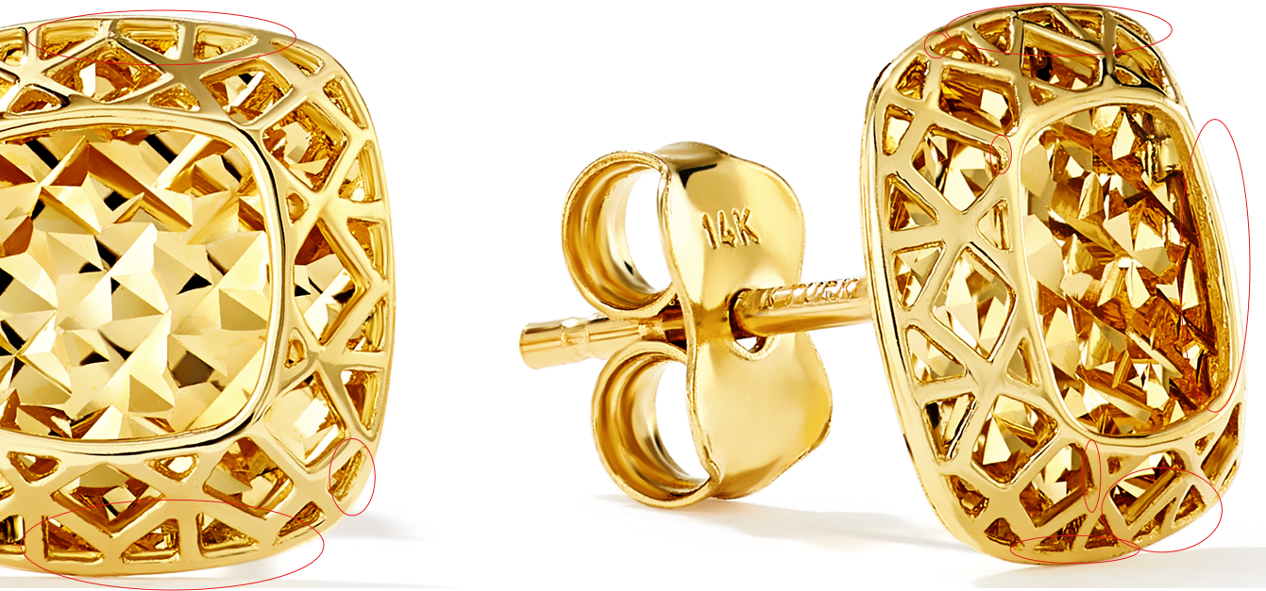

GCH20167R4-0-0
fix in chain photos

GCH20167R4-0-0
fix in chain photos

GCH20166W4-0-0
please make reflection even and natural in image A & B

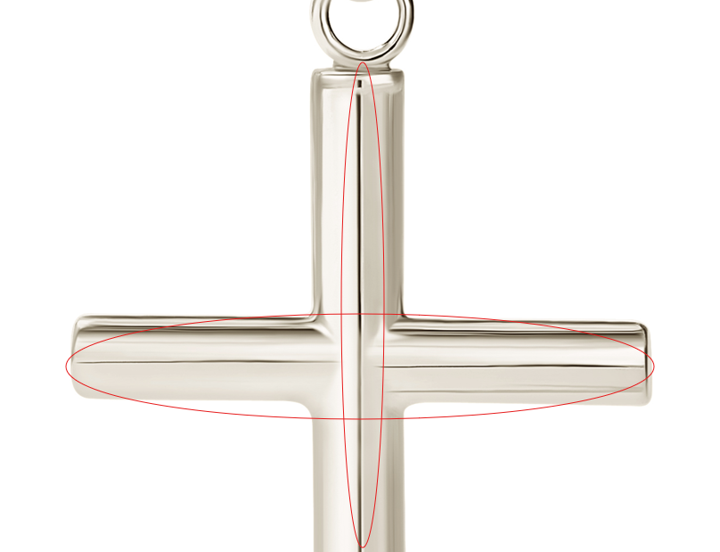

GCH20166W0-0-0

please make reflection even and natural in image A & B

GCH20166Y4-0-0
please make reflection even in image A & B

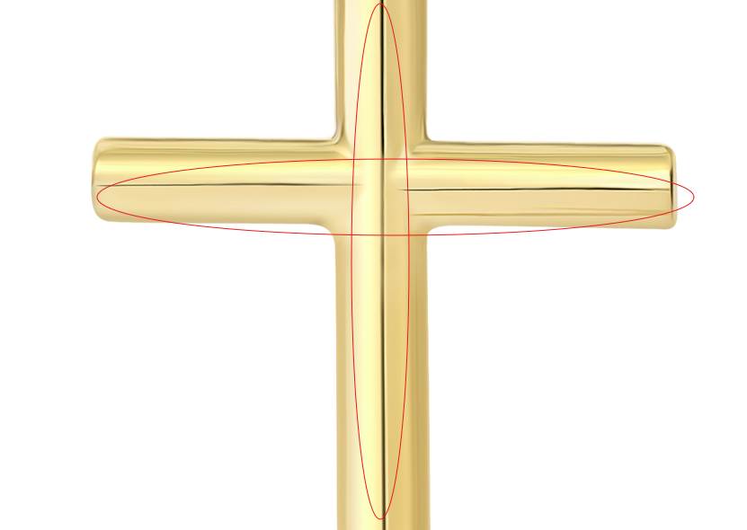

GCH15483Y4-0-0

20.4 X 17.95 X 2.0MM

GCH14795T0-0-0
please photoshop to 10kt and change to GCH14795T0-0-0

GCH14795T0-0-0
please clean up marks
please photoshop to 10kt and change to GCH14795T0-0-0

