GCH20168T4-0-0
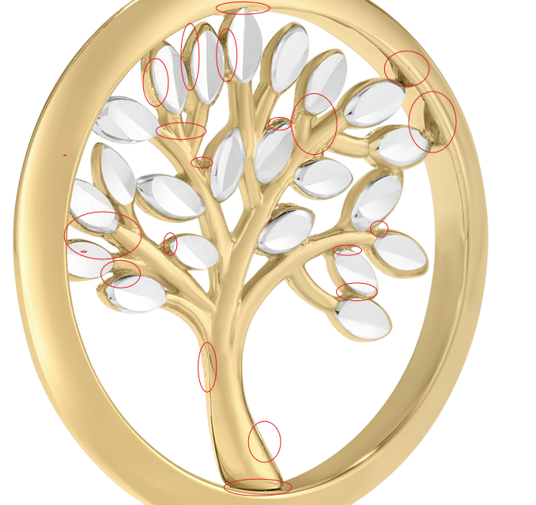

Please fic in Image B too﻿

